Recommendation: Approve

BALTIMORE CITY

Building, Precinct, and Polling Places comparison 2022 to 2026

 | 2022 | 2024 | 2026
Number of individual buildings | 186 | 176 | 174
Number of precincts | 296 | 295 | 295
Number of polling places | 186 | 181 | 174

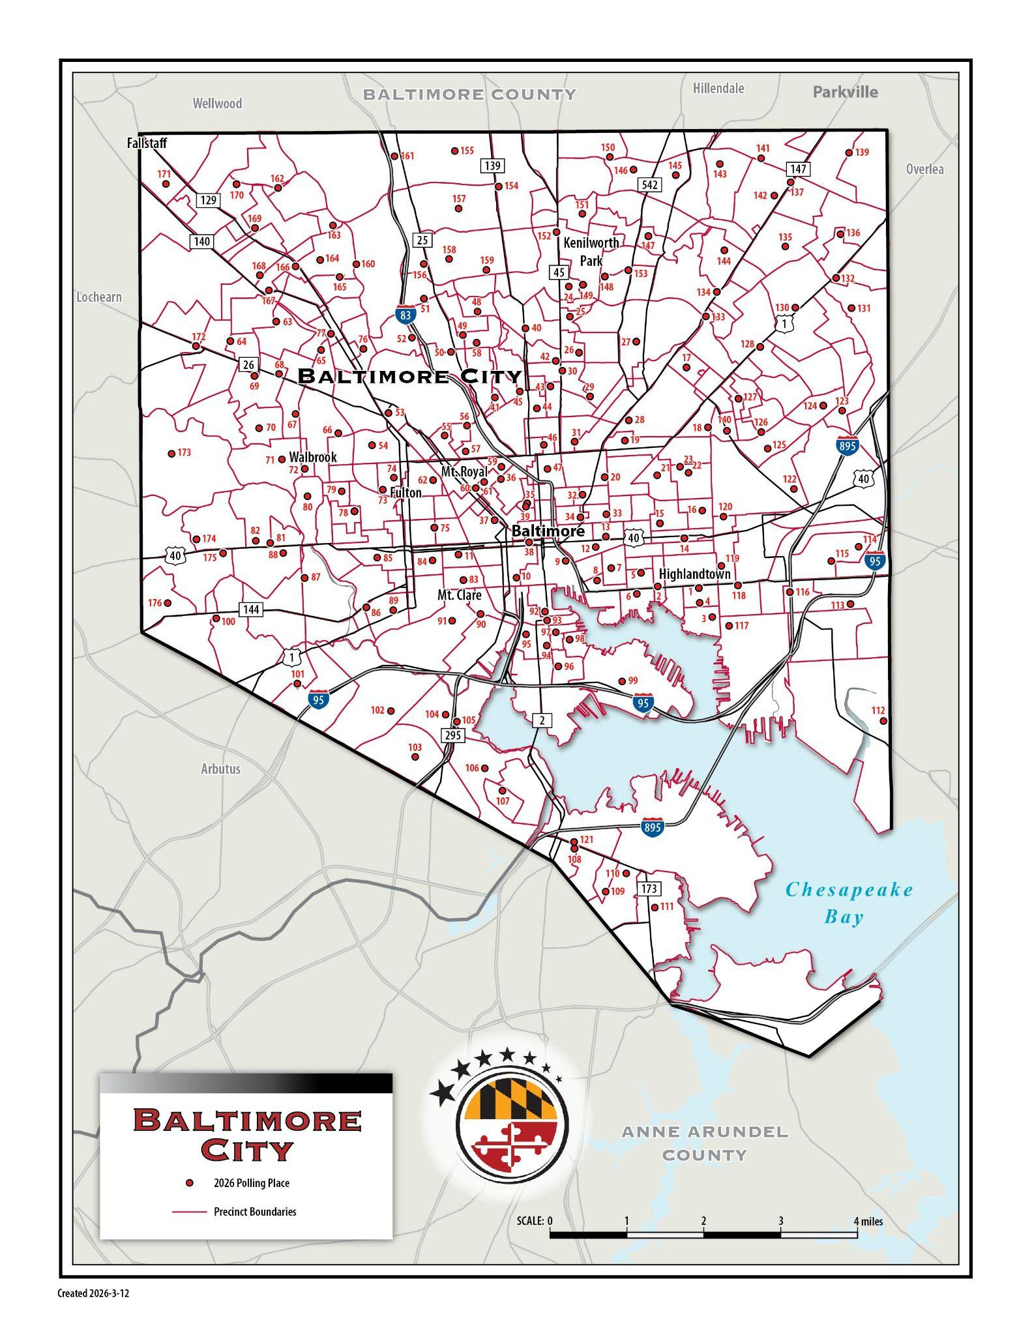
Baltimore City - 2026 Precinct and Polling Place map
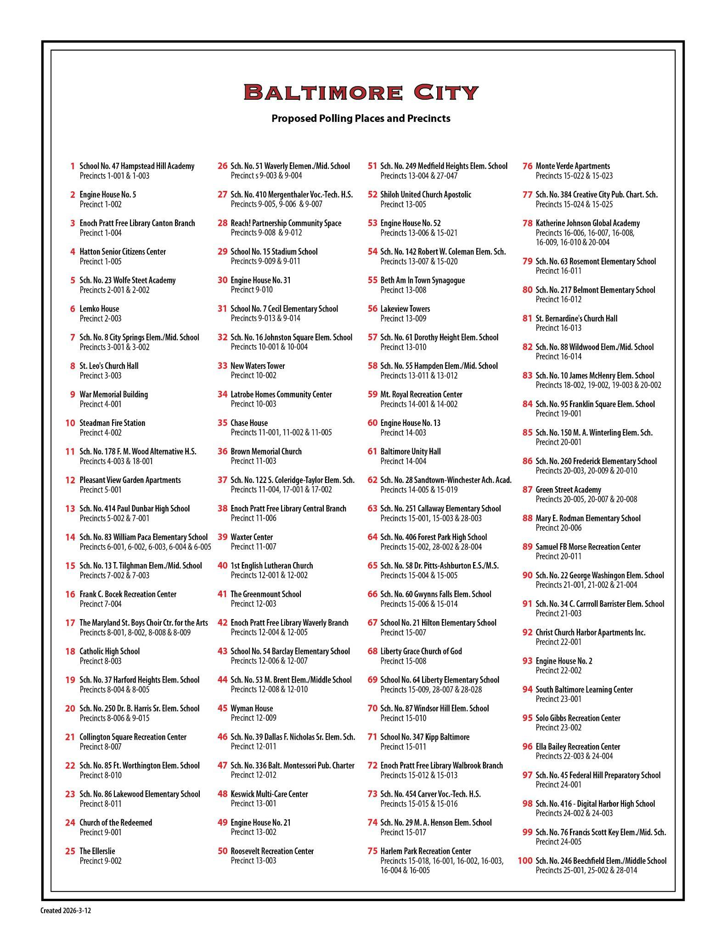
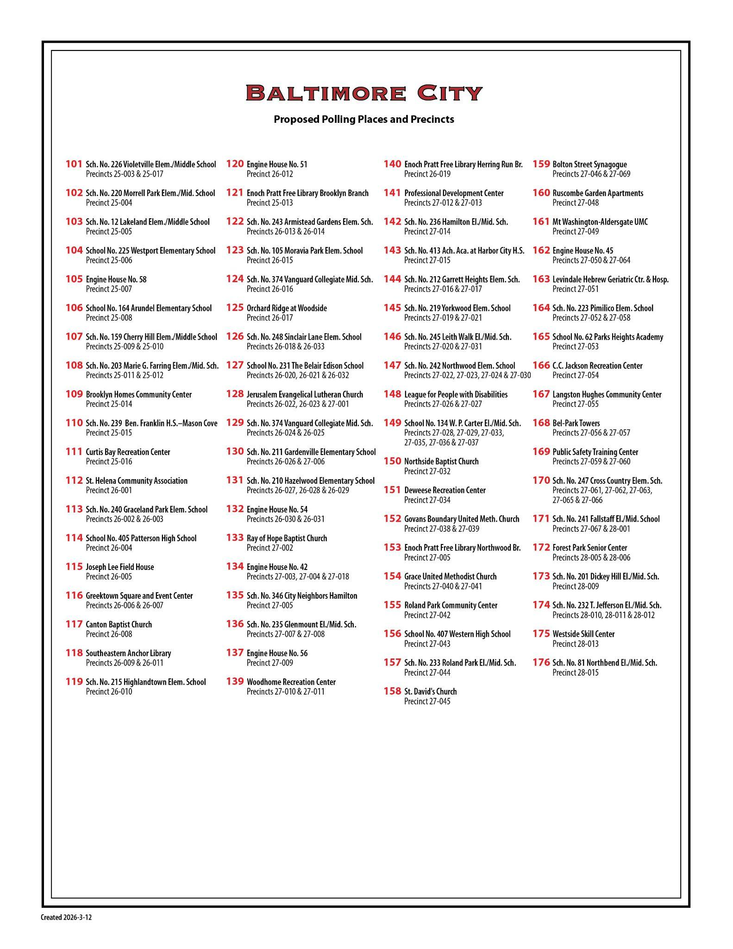

Baltimore City - 2026 Polling Locations

PRECINCT | POLLING PLACE | ADDRESS | SUITABLE FOR ELECTION | LOCATED NEAR MAJORITY OF VOTERS | ADA COMPLIANT | PUBLIC BUILDING | BUILDING TYPE | POLLING PLACE IN PRECINCT | PRECINCT WHERE POLLING PLACE IS LOCATED
1001 | SCHOOL #47 HAMPSTEAD HILL ACAD | 500 S LINWOOD AVE | Yes | Yes | Yes | Yes | School | Yes | 1001
1002 | ENGINE HOUSE #5 | 2120 EASTERN AVE | Yes | Yes | Yes | Yes | Firehouse | Yes | 1002
1003 | SCHOOL #47 HAMPSTEAD HILL ACAD | 500 S LINWOOD AVE | Yes | Yes | Yes | Yes | School | No | 1001
1004 | ENOCH PRATT FREE LIBRARY CANTON BRANCH | 1030 S ELLWOOD AVE | Yes | Yes | Yes | Yes | Library | Yes | 1004
1005 | HATTON SENIOR CITIZEN CTR | 2825 FAIT AVE | Yes | Yes | Yes | Yes | Senior Center | Yes | 1005
2001 | SCHOOL #23 WOLFE STREET ACAD | 245 S WOLFE ST | Yes | Yes | Yes | Yes | School | No | 2002
2002 | SCHOOL #23 WOLFE STREET ACAD | 245 S WOLFE ST | Yes | Yes | Yes | Yes | School | Yes | 2002
2003 | LEMKO HOUSE | 603 S ANN ST | Yes | Yes | Yes | No | Community Room | Yes | 2003
3001 | SCHOOL #8 CITY SPRINGS ELEM/MIDDLE | 100 S CAROLINE ST | Yes | Yes | Yes | Yes | School | Yes | 3001
3002 | SCHOOL #8 CITY SPRINGS ELEM/MIDDLE | 100 S CAROLINE ST | Yes | Yes | Yes | Yes | School | No | 3001
3003 | ST LEOS CHURCH HALL | 225 S EXETER ST | Yes | Yes | Yes | No | Church Hall | Yes | 3003
4001 | WAR MEMORIAL BUILDING | 101 N GAY STREET (ENTER ON LEXINGTON ST) | Yes | Yes | Yes | Yes | Museum/Gathering Space | Yes | 4001
4002 | STEADMAN FIRE STATION | 15 S EUTAW ST | Yes | Yes | Yes | Yes | Firehouse | Yes | 4002
4003 | SCHOOL #178 FRANCIS M. WOOD ALTERNATIVE HIGH | 1001 W Saratoga ST, 21223 | Yes | Yes | Yes | Yes | School | No | 18001
5001 | PLEASANT VIEW GARDEN APARTMENTS | 201 N AISQUITH ST | Yes | Yes | Yes | No | Community Room | Yes | 5001
5002 | SCHOOL #414 PAUL DUNBAR HIGH SCH | 1400 ORLEANS STREET - MAIN ENTRANCE | Yes | Yes | Yes | Yes | School | Yes | 5002
6001 | SCHOOL #83 WM PACA ELEM | 200 N LAKEWOOD AVE | Yes | Yes | Yes | Yes | School | No | 6002
6002 | SCHOOL #83 WM PACA ELEM | 200 N LAKEWOOD AVE | Yes | Yes | Yes | Yes | School | Yes | 6002
6003 | SCHOOL #83 WM PACA ELEM | 200 N LAKEWOOD AVE | Yes | Yes | Yes | Yes | School | No | 6002
6004 | SCHOOL #83 WM PACA ELEM | 200 N LAKEWOOD AVE | Yes | Yes | Yes | Yes | School | No | 6002
6005 | SCHOOL #83 WM PACA ELEM | 200 N LAKEWOOD AVE | Yes | Yes | Yes | Yes | School | No | 6002
7001 | SCHOOL #414 PAUL DUNBAR HIGH SCH | 1400 ORLEANS STREET - MAIN ENTRANCE | Yes | Yes | Yes | Yes | School | No | 5002
7002 | SCHOOL #13 TENCH TILGHMAN ELEM | 600 N PATTERSON PARK AVE | Yes | Yes | Yes | Yes | School | No | 7003
7003 | SCHOOL #13 TENCH TILGHMAN ELEM | 600 N PATTERSON PARK AVE | Yes | Yes | Yes | Yes | School | Yes | 7003
7004 | FRANK C BOCEK RECREATION CENTER | 3000 E MADISON ST | Yes | Yes | Yes | Yes | Rec Center | Yes | 7004
8001 | THE MARYLAND STATE BOYS CHOIR CENTER FOR THE ARTS | 3400 NORMAN AVE | Yes | Yes | Yes | No | Choir Room | No | 8008
8002 | THE MARYLAND STATE BOYS CHOIR CENTER FOR THE ARTS | 3400 NORMAN AVE | Yes | Yes | Yes | No | Choir Room | No | 8008
8003 | CATHOLIC HIGH SCHOOL | 2800 EDISON HWY | Yes | Yes | Yes | No | Entry Lobby | Yes | 8003
8004 | SCHOOL #37 HARFORD HTS PRIMARY | 1919 N BROADWAY | Yes | Yes | Yes | Yes | School | No | 8005
8005 | SCHOOL #37 HARFORD HTS PRIMARY | 1919 N BROADWAY | Yes | Yes | Yes | Yes | School | Yes | 8005
8006 | SCHOOL #250 DR. BERNARD HARRIS SR ELEM | 1400 N CAROLINE ST | Yes | Yes | Yes | Yes | School | No | 9015
8007 | COLLINGTON SQUARE RECREATION CENTER | 1409 N COLLINGTON AVE | Yes | Yes | Yes | Yes | School | Yes | 8007
8008 | THE MARYLAND STATE BOYS CHOIR CENTER FOR THE ARTS | 3400 NORMAN AVE | Yes | Yes | Yes | No | Choir Room | Yes | 8008
8009 | THE MARYLAND STATE BOYS CHOIR CENTER FOR THE ARTS | 3400 NORMAN AVE | Yes | Yes | Yes | No | Choir Room | No | 8008
8010 | SCHOOL #85 FT WORTHINGTON ELEM | 2701 E OLIVER ST | Yes | Yes | Yes | Yes | School | Yes | 8010
8011 | SCHOOL #86 LAKEWOOD ELEM | 2625 FEDERAL ST | Yes | Yes | Yes | Yes | School | Yes | 8011
9001 | CHURCH OF THE REDEEMED | 4321 OLD YORK RD | Yes | Yes | Yes | No | Community Room | Yes | 9001
9002 | THE ELLERSLIE | 601 WYANOKE AVE | Yes | Yes | Yes | Yes | Public Housing | Yes | 9002
9003 | SCHOOL #51 WAVERLY ELEM | 3400 ELLERSLIE AVE-ENTRANCE 34TH ST | Yes | Yes | Yes | Yes | School | Yes | 9003
9004 | SCHOOL #51 WAVERLY ELEM | 3400 ELLERSLIE AVE-ENTRANCE 34TH ST | Yes | Yes | Yes | Yes | School | No | 9003
9005 | SCHOOL #410 MERVO TECH HIGH | 3500 HILLEN RD - ENTRANCE TIVOLY AVE | Yes | Yes | Yes | Yes | School | No | 9006
9006 | SCHOOL #410 MERVO TECH HIGH | 3500 HILLEN RD - ENTRANCE TIVOLY AVE | Yes | Yes | Yes | Yes | School | Yes | 9006
9007 | SCHOOL #410 MERVO TECH HIGH | 3500 HILLEN RD - ENTRANCE TIVOLY AVE | Yes | Yes | Yes | Yes | School | No | 9006
9008 | REACH PARTNERSHIP - COMMUNITY SPACE | 2555 HARFORD ROAD | Yes | Yes | Yes | Yes | School | Yes | 9008
9009 | SCHOOL #15 STADIUM SCHOOL | 1400 EXETER HALL AVE | Yes | Yes | Yes | Yes | School | Yes | 9009
9010 | ENGINE HOUSE #31 | 3123 GREENMOUNT AVE | Yes | Yes | Yes | Yes | Firehouse | Yes | 9010
9011 | SCHOOL #15 STADIUM SCHOOL | 1400 EXETER HALL AVE | Yes | Yes | Yes | Yes | School | No | 9009
9012 | REACH PARTNERSHIP - COMMUNITY SPACE | 2555 HARFORD ROAD | Yes | Yes | Yes | Yes | School | No | 9008
9013 | SCHOOL #7 CECIL ELEM | 2000 CECIL AVE | Yes | Yes | Yes | Yes | School | No | 9014
9014 | SCHOOL #7 CECIL ELEM | 2000 CECIL AVE | Yes | Yes | Yes | Yes | School | Yes | 9014
9015 | SCHOOL #250 BERNARD HARRIS SCHOOL | 1400 N CAROLINE ST | Yes | Yes | Yes | Yes | School | Yes | 9015
10001 | SCHOOL #16 JOHNSTON SQ ELEM | 1101 VALLEY ST | Yes | Yes | Yes | Yes | School | Yes | 10001
10002 | NEW WATERS TOWER APARTMENTS | 1400 E MADISON ST | Yes | Yes | Yes | No | Community Room | Yes | 10002
10003 | LATROBE HOMES COMMUNITY CENTER | 900 E MADISON ST | Yes | Yes | Yes | Yes | Community Center | Yes | 10003
10004 | SCHOOL #16 JOHNSTON SQ ELEM | 1101 VALLEY ST | Yes | Yes | Yes | Yes | School | No | 10001
11001 | CHASE HOUSE | 1027 CATHEDRAL ST | Yes | Yes | Yes | Yes | Pubic Housing | No | 11002
11002 | CHASE HOUSE | 1027 CATHEDRAL ST | Yes | Yes | Yes | Yes | Public Housing | Yes | 11002
11003 | BROWN MEMORIAL CHURCH | 1316 PARK AVENUE | Yes | Yes | Yes | No | Community Room | Yes | 11003
11004 | SCHOOL #122 SAMUEL COLERIDGE-TAYLOR ELEM | 507 W PRESTON ST - ENTER ON DRUID HILL AVE | Yes | Yes | Yes | Yes | School | No | 17002
11005 | CHASE HOUSE | 1027 CATHEDRAL ST | Yes | Yes | Yes | Yes | Public Housing | No | 11002
11006 | ENOCH PRATT FREE LIBRARY CENTRAL BRANCH | 400 CATHEDRAL ST | Yes | Yes | Yes | Yes | Library | Yes | 11006
11007 | WAXTER CENTER | 1000 CATHEDRAL ST | Yes | Yes | Yes | Yes | Senior Citizen Center | Yes | 11007
12001 | 1ST ENGLISH LUTHERAN CHURCH | 3807 N CHARLES ST | Yes | Yes | Yes | No | Community Room | Yes | 12001
12002 | 1ST ENGLISH LUTHERAN CHURCH | 3807 N CHARLES ST | Yes | Yes | Yes | No | Community Room | No | 12001
12003 | THE GREENMOUNT SCHOOL | 501 W 30TH ST | Yes | Yes | Yes | Yes | School | Yes | 12003
12004 | ENOCH PRATT FREE LIBRARY WAVERLY BRANCH | 400 E 33RD ST | Yes | Yes | Yes | Yes | Library | Yes | 12004
12005 | ENOCH PRATT FREE LIBRARY WAVERLY BRANCH | 400 E 33RD ST | Yes | Yes | Yes | Yes | Library | No | 12004
12006 | SCHOOL #54 BARCLAY ELEM | 2900 BARCLAY ST | Yes | Yes | Yes | Yes | School | No | 12007
12007 | SCHOOL #54 BARCLAY ELEM | 2900 BARCLAY ST | Yes | Yes | Yes | Yes | School | Yes | 12007
12008 | SCHOOL #53 BRENT ELEM | 100 E 26TH ST | Yes | Yes | Yes | Yes | School | Yes | 12008
12009 | WYMAN HOUSE | 123 W 29TH ST | Yes | Yes | Yes | No | Community Room | Yes | 12009
12010 | SCHOOL #53 BRENT ELEM | 100 E 26TH ST | Yes | Yes | Yes | Yes | School | No | 12008
12011 | SCHOOL #39 DALLAS F. NICHOLAS SR ELEM | 201 E 21ST ST | Yes | Yes | Yes | Yes | School | Yes | 12011
12012 | BALTO MONTESSORI PUBLIC CHARTER SCH 336 | 1600 GUILFORD AVE | Yes | Yes | Yes | Yes | School | Yes | 12012
13001 | KESWICK MULTICARE CTR | 700 W 40TH ST | Yes | Yes | Yes | No | Rehab Center | Yes | 13001
13002 | ENGINE HOUSE #21 | 3724 ROLAND AVE | Yes | Yes | Yes | Yes | Firehouse | Yes | 13002
13003 | ROOSEVELT RECREATION CENTER | 1221 W 36TH STREET | Yes | Yes | Yes | Yes | Rec Center | Yes | 13003
13004 | SCHOOL #249 MEDFIELD HEIGHTS ELEM | 4300 BUCHANAN AVE | Yes | Yes | Yes | Yes | School | Yes | 13004
13005 | SHILOH UNITED CHURCH APOSTOLIC | 2000 DRUID PARK DRIVE | Yes | Yes | Yes | No | Community Room | Yes | 13005
13006 | ENGINE HOUSE #52 | 3525 WOODBROOK AVE | Yes | Yes | Yes | Yes | School | Yes | 13006
13007 | ROBERT W. COLEMAN ELEM | 2400 WINDSOR AVE | Yes | Yes | Yes | Yes | School | No | 15020
13008 | BETH AM IN TOWN SYNAGOGUE | 2501 EUTAW PL | Yes | Yes | Yes | No | Community Room | Yes | 13008
13009 | LAKEVIEW TOWERS | 727 DRUID PARK LAKE DRIVE | Yes | Yes | Yes | No | Community Room | Yes | 13009
13010 | SCHOOL #61 DOROTHY HEIGHT ELEM | 2011 LINDEN AVENUE | Yes | Yes | Yes | Yes | School | Yes | 13010
13011 | SCHOOL #55 HAMPDEN ELEM | 3608 CHESTNUT AVE | Yes | Yes | Yes | Yes | School | No | 13012
13012 | SCHOOL #55 HAMPDEN ELEM | 3608 CHESTNUT AVE | Yes | Yes | Yes | Yes | School | Yes | 13012
14001 | MT ROYAL RECREATION CTR | 120 W MOSHER ST | Yes | Yes | Yes | Yes | Rec Center | Yes | 14001
14002 | MT ROYAL RECREATION CTR | 120 W MOSHER ST | Yes | Yes | Yes | Yes | Rec Center | No | 14001
14003 | ENGINE HOUSE #13 | 405 MCMECHEN ST | Yes | Yes | Yes | Yes | Firehouse | Yes | 14003
14004 | BALTIMORE UNITY HALL | 1505 EUTAW PL | Yes | Yes | Yes | No | Community Center | Yes | 14004
14005 | SANDTOWN WINCHESTER ACADEMY | 701 Gold Street | Yes | Yes | Yes | No | School | Yes | 14005
15001 | SCHOOL #251 CALLAWAY ELEM | 3701 FERNHILL AVE | Yes | Yes | Yes | Yes | School | No | 15003
15002 | SCHOOL #406 FOREST PARK SENIOR HIGH | 3701 ELDORADO AVE (ENTER ON BELLE AVE) | Yes | Yes | Yes | Yes | School | Yes | 15002
15003 | SCHOOL #251 CALLAWAY ELEM | 3701 FERNHILL AVE | Yes | Yes | Yes | Yes | School | No | 15003
15004 | SCHOOL #58 DR NATHAN A PITTS-ASHBURTON ELEM/MID | 3935 HILTON RD | Yes | Yes | Yes | Yes | School | No | 15005
15005 | SCHOOL #58 DR NATHAN A PITTS-ASHBURTON ELEM/MID | 3935 HILTON RD | Yes | Yes | Yes | Yes | School | Yes | 15005
15006 | SCHOOL #60 GWYNNS FALLS ELEM | 2700 GWYNNS FALLS PKWY | Yes | Yes | Yes | Yes | School | Yes | 15006
15007 | SCHOOL #21 HILTON ELEM | 3301 CARLISLE AVE | Yes | Yes | Yes | Yes | School | Yes | 15007
15008 | LIBERTY GRACE CHURCH OF GOD | 3400 COPLEY RD | Yes | Yes | Yes | Yes | School | Yes | 15008
15009 | SCHOOL #64 LIBERTY ELEM | 3901 MAINE AVE | Yes | Yes | Yes | Yes | School | Yes | 15009
15010 | SCHOOL #87 WINDSOR HILL ELEM | 4001 ALTO RD | Yes | Yes | Yes | Yes | School | Yes | 15010
15011 | SCHOOL #347 KIPP BALTIMORE | 2000 EDGEWOOD ST | Yes | Yes | Yes | Yes | School | Yes | 15011
15012 | ENOCH PRATT FREE LIBRARY WALBROOK BRANCH | 3203 W NORTH AVE | Yes | Yes | Yes | Yes | Library | Yes | 15012
15013 | ENOCH PRATT FREE LIBRARY WALBROOK BRANCH | 3203 W NORTH AVE | Yes | Yes | Yes | Yes | Library | No | 15012
15014 | SCHOOL #60 GWYNNS FALLS ELEM | 2700 GWYNNS FALLS PKWY | Yes | Yes | Yes | Yes | School | No | 15006
15015 | SCHOOL #454 CARVER VOC-TECH HIGH | 2201 PRESSTMAN ST | Yes | Yes | Yes | Yes | School | No | 15016
15016 | SCHOOL #454 CARVER VOC-TECH HIGH | 2201 PRESSTMAN ST | Yes | Yes | Yes | Yes | School | Yes | 15016
15017 | SCHOOL #29 MATTHEW HENSON ELEM | 1600 N PAYSON ST | Yes | Yes | Yes | Yes | School | Yes | 15017
15018 | HARLEM PARK RECREATION CENTER | 700 N CALHOUN ST | Yes | Yes | Yes | Yes | Rec Center | No | 16003
15019 | SCHOOL #28 SANDTOWN-WINCHESTER ACHIEVEMENT ACAD | 701 GOLD ST | Yes | Yes | Yes | Yes | School | Yes | 15019
15020 | ROBERT W. COLEMAN ELEM | 2400 WINDSOR AVE | Yes | Yes | Yes | Yes | School | Yes | 15020
15021 | ENGINE HOUSE #52 | 3525 WOODBROOK AVE | Yes | Yes | Yes | Yes | Firehouse | No | 13006
15022 | MONTE VERDE APARTMENTS | 2503 VIOLET AVE | Yes | Yes | Yes | No | Community Room | No | 15023
15023 | MONTE VERDE APARTMENTS | 2503 VIOLET AVE | Yes | Yes | Yes | No | Community Room | Yes | 15023
15024 | CREATIVE CITY PUBLIC CHARTER SCH #384 | 2810 SHIRLEY AVENUE | Yes | Yes | Yes | Yes | School | Yes | 15024
15025 | CREATIVE CITY PUBLIC CHARTER SCH #384 | 2810 SHIRLEY AVENUE | Yes | Yes | Yes | Yes | School | No | 15024
16001 | HARLEM PARK RECREATION CENTER | 700 N CALHOUN ST | Yes | Yes | Yes | Yes | Rec Center | No | 16003
16002 | HARLEM PARK RECREATION CENTER | 700 N CALHOUN ST | Yes | Yes | Yes | Yes | Rec Center | No | 16003
16003 | HARLEM PARK RECREATION CENTER | 700 N CALHOUN ST | Yes | Yes | Yes | Yes | Rec Center | Yes | 16003
16004 | HARLEM PARK RECREATION CENTER | 700 N CALHOUN ST | Yes | Yes | Yes | Yes | Rec Center | No | 16003
16005 | HARLEM PARK RECREATION CENTER | 700 N CALHOUN ST | Yes | Yes | Yes | Yes | Rec Center | No | 16003
16006 | KATHERINE JOHNSON GLOBAL ACADEMY | 1101 BRADDISH AVE | Yes | Yes | Yes | Yes | School | No | 16010
16007 | KATHERINE JOHNSON GLOBAL ACADEMY | 1101 BRADDISH AVE | Yes | Yes | Yes | Yes | School | No | 16010
16008 | KATHERINE JOHNSON GLOBAL ACADEMY | 1101 BRADDISH AVE | Yes | Yes | Yes | Yes | School | No | 16010
16009 | KATHERINE JOHNSON GLOBAL ACADEMY | 1101 BRADDISH AVE | Yes | Yes | Yes | Yes | School | No | 16010
16010 | KATHERINE JOHNSON GLOBAL ACADEMY | 1101 BRADDISH AVE | Yes | Yes | Yes | Yes | School | Yes | 16010
16011 | SCHOOL #63 ROSEMONT ELEM | 2777 PRESSTMAN ST | Yes | Yes | Yes | Yes | School | Yes | 16011
16012 | SCHOOL #217 BELMONT ELEM | 1406 N ELLAMONT ST | Yes | Yes | Yes | Yes | School | Yes | 16012
16013 | ST BERNARDINES CHURCH HALL | 614 MT HOLLY ST | Yes | Yes | Yes | No | Community Room | Yes | 16013
16014 | SCHOOL #88 WILDWOOD ELEM/MIDDLE | 621 WILDWOOD PKWY | Yes | Yes | Yes | Yes | School | Yes | 16014
17001 | SCHOOL #122 SAMUEL COLERIDGE-TAYLOR ELEM | 507 W PRESTON ST - ENTER ON DRUID HILL AVE | Yes | Yes | Yes | Yes | School | No | 17002
17002 | SCHOOL #122 SAMUEL COLERIDGE-TAYLOR ELEM | 507 W PRESTON ST - ENTER ON DRUID HILL AVE | Yes | Yes | Yes | Yes | School | Yes | 17002
18001 | SCHOOL #178 FRANCIS M. WOOD ALTERNATIVE HIGH | 1001 W SARATOGA ST | Yes | Yes | Yes | Yes | School | No | 18001
18002 | SCHOOL #10 MCHENRY ELEM | 31 S SCHROEDER ST | Yes | Yes | Yes | Yes | School | Yes | 18002
19001 | SCHOOL #95 FRANKLIN SQ ELEM | 1400 W LEXINGTON ST | Yes | Yes | Yes | Yes | School | Yes | 19001
19002 | JAMES MCHENRY SCHOOL | 31 S. Schroeder ST | Yes | Yes | Yes | Yes | School | No | 18002
19003 | JAMES MCHENRY SCHOOL | 31 S. Schroeder ST | Yes | Yes | Yes | Yes | School | No | 18002
20001 | SCHOOL #150 MARY ANN WINTERLING ELEM | 220 N BENTALOU ST | Yes | Yes | Yes | Yes | School | Yes | 20001
20002 | JAMES MCHENRY SCHOOL | 31 S. Schroeder ST | Yes | Yes | Yes | Yes | School | No | 18002
20003 | SCHOOL #260 FREDERICK ELEM | 2501 FREDERICK AVENUE | Yes | Yes | Yes | Yes | School | No | 20010
20004 | KATHERINE JOHNSON GLOBAL ACADEMY | 1101 BRADDISH AVE | Yes | Yes | Yes | Yes | School | No | 16010
20005 | GREEN STREET ACADEMY | 125 N HILTON ST | Yes | Yes | Yes | No | School | Yes | 20005
20006 | MARY RODMAN ELEM | 3510 MULBERRY ST | Yes | Yes | Yes | Yes | School | No | 20006
20007 | GREEN STREET ACADEMY | 125 N HILTON ST | Yes | Yes | Yes | No | School | No | 20005
20008 | GREEN STREET ACADEMY | 125 N HILTON ST | Yes | Yes | Yes | No | School | No | 20005
20009 | SCHOOL #260 FREDERICK ELEM | 2501 FREDERICK AVENUE | Yes | Yes | Yes | Yes | School | No | 20010
20010 | SCHOOL #260 FREDERICK ELEM | 2501 FREDERICK AVENUE | Yes | Yes | Yes | Yes | School | No | 20010
20011 | SAMUEL F B MORSE | 424 S PULASKI ST | Yes | Yes | Yes | Yes | School | No | 20011
21001 | SCHOOL #22 GEORGE WASHINGTON ELEM | 800 SCOTT ST | Yes | Yes | Yes | Yes | School | No | 21002
21002 | SCHOOL #22 GEORGE WASHINGTON ELEM | 800 SCOTT ST | Yes | Yes | Yes | Yes | School | Yes | 21002
21003 | SCHOOL #34 CHARLES CARROLL ELEM | 1327 WASHINGTON BLVD | Yes | Yes | Yes | Yes | School | Yes | 21003
21004 | SCHOOL #22 GEORGE WASHINGTON ELEM | 800 SCOTT ST | Yes | Yes | Yes | Yes | School | No | 21002
22001 | CHRIST CHURCH HARBOR APTS. INC. | 600 LIGHT STREET | Yes | Yes | Yes | No | Community Room | Yes | 22001
22002 | ENGINE HOUSE #2 | 800 LIGHT ST | Yes | Yes | Yes | Yes | Firehouse | Yes | 22002
23001 | SOUTH BALTIMORE LEARNING CTR | 28 E OSTEND ST-ENTRANCE PATAPSCO ST | Yes | Yes | Yes | Yes | Community Center | Yes | 23001
23002 | SOLO GIBBS REC CTR | 1044 LEADENHALL ST AT CROSS ST | Yes | Yes | Yes | Yes | Rec Center | Yes | 23002
23003 | ELLA BAILEY REC CTR | 100 E HEATH ST | Yes | Yes | Yes | Yes | Rec Center | No | 24004
24001 | SCHOOL #45 FEDERAL HILL PREP ACAD | 1040 WILLIAM ST | Yes | Yes | Yes | Yes | School | Yes | 24001
24002 | SCHOOL #416 DIGITAL HARBOR HIGH | 1100 COVINGTON ST | Yes | Yes | Yes | Yes | School | No | 24003
24003 | SCHOOL #416 DIGITAL HARBOR HIGH | 1100 COVINGTON ST | Yes | Yes | Yes | Yes | School | Yes | 24003
24004 | ELLA BAILEY REC CTR | 100 E HEATH ST | Yes | Yes | Yes | Yes | Rec Center | Yes | 24004
24005 | SCHOOL #76 F SCOTT KEY ELEM | 1425 E FORT AVE | Yes | Yes | Yes | Yes | School | Yes | 24005
25001 | SCHOOL #246 BEECHFIELD ELEM | 301 S BEECHFIELD AVE | Yes | Yes | Yes | Yes | School | No | 25002
25002 | SCHOOL #246 BEECHFIELD ELEM | 301 S BEECHFIELD AVE | Yes | Yes | Yes | Yes | School | Yes | 25002
25003 | SCHOOL #226 VIOLETVILLE ELEM/MID | 1207 PINE HGTS AVE | Yes | Yes | Yes | Yes | School | No | 25017
25004 | SCHOOL #220 MORRELL PARK ELEM/MID | 2601 TOLLEY ST | Yes | Yes | Yes | Yes | School | Yes | 25004
25005 | SCHOOL #12 LAKELAND ELEM/MID | 2921 STRANDEN RD (REC CTR) | Yes | Yes | Yes | Yes | School | Yes | 25005
25006 | SCHOOL #225 WESTPORT ELEM | 2401 NEVADA ST | Yes | Yes | Yes | Yes | School | Yes | 25006
25007 | ENGINE HOUSE #58 | 2425 1/2 ANNAPOLIS RD | Yes | Yes | Yes | Yes | Firehouse | Yes | 25007
25008 | SCHOOL #164 ARUNDEL ELEM | 2400 ROUND RD | Yes | Yes | Yes | Yes | School | Yes | 25008
25009 | SCHOOL #159 CHERRY HILL ELEM | 801 BRIDGEVIEW ROAD | Yes | Yes | Yes | Yes | School | Yes | 25009
25010 | SCHOOL #159 CHERRY HILL ELEM | 801 BRIDGEVIEW ROAD | Yes | Yes | Yes | Yes | School | No | 25009
25011 | SCHOOL #203 MARIE FARRING ELEM | 300 PONTIAC AVE | Yes | Yes | Yes | Yes | School | Yes | 25011
25012 | SCHOOL #203 MARIE FARRING ELEM | 300 PONTIAC AVE | Yes | Yes | Yes | Yes | School | No | 25011
25013 | ENOCH PRATT FREE LIBRARY BROOKLYN BRANCH | 300 E PATAPSCO AVE | Yes | Yes | Yes | Yes | Library | Yes | 25013
25014 | BROOKLYN HOMES COMMUNITY CENTER | 4140 TENTH ST | Yes | Yes | Yes | Yes | Community Center | Yes | 25014
25015 | SCHOOL #239 MASONVILLE COVE @ BEN FRANKLIN | 1201 CAMBRIA ST | Yes | Yes | Yes | Yes | School | Yes | 25015
25016 | CURTIS BAY REC CTR | 1630 FILBERT ST | Yes | Yes | Yes | Yes | Rec Center | Yes | 25016
25017 | SCHOOL #226 VIOLETVILLE ELEM/MID | 1207 PINE HGTS AVE | Yes | Yes | Yes | Yes | School | Yes | 25017
26001 | ST HELENA COMMUNITY ASSOC | 6509 COLGATE AVE | Yes | Yes | Yes | Yes | Community Center | Yes | 26001
26002 | SCHOOL #240 GRACELAND PARK ELEM | 6300 ODONNELL ST | Yes | Yes | Yes | Yes | School | No | 26003
26003 | SCHOOL #240 GRACELAND PARK ELEM | 6300 ODONNELL ST | Yes | Yes | Yes | Yes | School | Yes | 26003
26004 | SCHOOL #405 PATTERSON SR HIGH | 100 KANE ST | Yes | Yes | Yes | Yes | School | Yes | 26004
26005 | JOSEPH LEE FIELDHOUSE | 5900 E PRATT ST | Yes | Yes | Yes | Yes | Rec Center | Yes | 26005
26006 | GREEKTOWN SQUARE AND EVENT CENTER | 700 S QUAIL ST | Yes | Yes | Yes | Yes | Community Space | Yes | 26006
26007 | GREEKTOWN SQUARE AND EVENT CENTER | 700 S QUAIL ST | Yes | Yes | Yes | Yes | Community Space | No | 26006
26008 | CANTON BAPTIST CHURCH | 3302 TOONE ST | Yes | Yes | Yes | No | Community Room | Yes | 26008
26009 | SOUTHEAST ANCHOR LIBRARY | 3601 EASTERN AVE | Yes | Yes | Yes | Yes | Library | Yes | 26009
26010 | SCHOOL #215 HIGHLANDTOWN ELEM | 3223 E PRATT ST | Yes | Yes | Yes | Yes | School | Yes | 26010
26011 | SOUTHEAST ANCHOR LIBRARY | 3601 EASTERN AVE | Yes | Yes | Yes | Yes | Library | No | 26009
26012 | ENGINE HOUSE #51 | 646 N HIGHLAND AVE | Yes | Yes | Yes | Yes | Firehouse | Yes | 26012
26013 | SCHOOL #243 ARMISTEAD GARDENS ELEM SCHOOL | 5001 E. EAGER ST | Yes | Yes | Yes | Yes | School | No | 26014
26014 | SCHOOL #243 ARMISTEAD GARDENS ELEM SCHOOL | 5001 E. EAGER ST | Yes | Yes | Yes | Yes | School | Yes | 26014
26015 | SCHOOL #105 MORAVIA PARK ELEM | 6001 FRANKFORD AVE | Yes | Yes | Yes | Yes | School | Yes | 26015
26016 | SCHOOL #374 VANGUARD COLLEGIATE MIDDLE | 5001 SINCLAIR LANE (REAR) ENTER ON TRUESDALE AVE. | Yes | Yes | Yes | Yes | School | Yes | 26016
26017 | ORCHARD RIDGE @ WOODSIDE | 4340 ORCHARD RIDGE BLVD | Yes | Yes | Yes | No | Public Housing | Yes | 26017
26018 | SCHOOL #248 SINCLAIR LANE ELEM | 3880 SINCLAIR LN | Yes | Yes | Yes | Yes | School | No | 26033
26019 | ENOCH PRATT FREE LIBRARY HERRING RUN BRANCH | 3801 ERDMAN AVE | Yes | Yes | Yes | Yes | Library | Yes | 26019
26020 | SCHOOL #231 THE BELAIR-EDISON SCHOOL | 3536 BREHMS LN | Yes | Yes | Yes | Yes | School | No | 26021
26021 | SCHOOL #231 THE BELAIR-EDISON SCHOOL | 3536 BREHMS LN | Yes | Yes | Yes | Yes | School | Yes | 26021
26022 | JERUSALEM EV LUTHERAN CHURCH | 4605 BELAIR RD | Yes | Yes | Yes | No | Community Room | No | 26023
26023 | JERUSALEM EV LUTHERAN CHURCH | 4605 BELAIR RD | Yes | Yes | Yes | No | Community Room | Yes | 26023
26024 | SCHOOL #374 VANGUARD COLLEGIATE MIDDLE | 5001 SINCLAIR LANE (REAR) ENTER ON TRUESDALE AVE. | Yes | Yes | Yes | Yes | School | No | 26016
26025 | SCHOOL #374 VANGUARD COLLEGIATE MIDDLE | 5001 SINCLAIR LANE (REAR) ENTER ON TRUESDALE AVE. | Yes | Yes | Yes | Yes | School | No | 26016
26026 | SCHOOL #211 GARDENVILLE ELEM | 5300 BELAIR RD | Yes | Yes | Yes | Yes | School | No | 27006
26027 | SCHOOL #210 HAZELWOOD ELEM | 4517 HAZELWOOD AVE | Yes | Yes | Yes | Yes | School | No | 26029
26028 | SCHOOL #210 HAZELWOOD ELEM | 4517 HAZELWOOD AVE | Yes | Yes | Yes | Yes | School | No | 26029
26029 | SCHOOL #210 HAZELWOOD ELEM | 4517 HAZELWOOD AVE | Yes | Yes | Yes | Yes | School | Yes | 26029
26030 | ENGINE HOUSE #54 | 5821 BELAIR RD | Yes | Yes | Yes | Yes | Firehouse | Yes | 26030
26031 | ENGINE HOUSE #54 | 5821 BELAIR RD | Yes | Yes | Yes | Yes | Firehouse | No | 26030
26032 | SCHOOL #231 THE BELAIR-EDISON SCHOOL | 3536 BREHMS LN | Yes | Yes | Yes | Yes | School | No | 26021
26033 | SCHOOL #248 SINCLAIR LANE ELEM | 3880 SINCLAIR LN | Yes | Yes | Yes | Yes | School | Yes | 26033
27001 | JERUSALEM EV LUTHERAN CHURCH | 4605 BELAIR RD | Yes | Yes | Yes | No | Community Room | No | 26023
27002 | RAY OF HOPE BAPTIST CHURCH | 3000 PARKSIDE DR | Yes | Yes | Yes | No | Community Room | Yes | 27002
27003 | ENGINE HOUSE #42 | 4522 HARFORD RD | Yes | Yes | Yes | Yes | Firehouse | No | 27018
27004 | ENGINE HOUSE #42 | 4522 HARFORD RD | Yes | Yes | Yes | Yes | Firehouse | No | 27018
27005 | SCHOOL #346 CITY NEIGHBORS HAMILTON | 5609 SEFTON AVE - REAR | Yes | Yes | Yes | Yes | School | Yes | 27005
27006 | SCHOOL #211 GARDENVILLE ELEM | 5300 BELAIR RD | Yes | Yes | Yes | Yes | School | Yes | 27006
27007 | SCHOOL #235 GLENMOUNT ELEM/MID | 6211 WALTHER AVE | Yes | Yes | Yes | Yes | School | Yes | 27007
27008 | SCHOOL #235 GLENMOUNT ELEM/MID | 6211 WALTHER AVE | Yes | Yes | Yes | Yes | School | No | 27007
27009 | ENGINE HOUSE #56 | 6512 HARFORD RD | Yes | Yes | Yes | Yes | Firehouse | Yes | 27009
27010 | WOODHOME REC CTR | 7310 MOYER AVE | Yes | Yes | Yes | Yes | Rec Center | No | 27011
27011 | WOODHOME REC CTR | 7310 MOYER AVE | Yes | Yes | Yes | Yes | Rec Center | Yes | 27011
27012 | PROFESSIONAL DEVELOPMENT CENTER | 2500 E NORTHERN PKWY | Yes | Yes | Yes | Yes | School | No | 27013
27013 | PROFESSIONAL DEVELOPMENT CENTER | 2500 E NORTHERN PKWY | Yes | Yes | Yes | Yes | School | Yes | 27013
27014 | SCHOOL #236 HAMILTON ELEM/MID | 6101 OLD HARFORD RD | Yes | Yes | Yes | Yes | School | Yes | 27014
27015 | SCHOOL #413 ACHIEVEMENT ACAD @ HARBOR CITY | 2201 PINEWOOD AVE | Yes | Yes | Yes | Yes | School | Yes | 27015
27016 | SCHOOL #212 GARRETT HGTS ELEM | 2800 AILSA AVE | Yes | Yes | Yes | Yes | School | No | 27017
27017 | SCHOOL #212 GARRETT HGTS ELEM | 2800 AILSA AVE | Yes | Yes | Yes | Yes | School | No | 27017
27018 | ENGINE HOUSE #42 | 4522 HARFORD RD | Yes | Yes | Yes | Yes | Firehouse | No | 27018
27019 | SCHOOL #219 YORKWOOD ELEM | 5931 YORKWOOD RD | Yes | Yes | Yes | Yes | School | No | 27021
27020 | SCHOOL #245 LEITH WALK ELEM SCH | 1235 SHERWOOD AVENUE | Yes | Yes | Yes | Yes | School | No | 27031
27021 | SCHOOL #219 YORKWOOD ELEM | 5931 YORKWOOD RD | Yes | Yes | Yes | Yes | School | Yes | 27021
27022 | SCHOOL #242 NORTHWOOD ELEM | 5201 LOCH RAVEN BLVD | Yes | Yes | Yes | Yes | School | No | 27023
27023 | SCHOOL #242 NORTHWOOD ELEM | 5201 LOCH RAVEN BLVD | Yes | Yes | Yes | Yes | School | Yes | 27023
27024 | SCHOOL #242 NORTHWOOD ELEM | 5201 LOCH RAVEN BLVD | Yes | Yes | Yes | Yes | School | No | 27023
27025 | ENOCH PRATT FREE LIBRARY NORTHWOOD BRANCH | 4420 LOCH RAVEN BLVD | Yes | Yes | Yes | No | Library | Yes | 27025
27026 | THE LEAGUE FOR PEOPLE WITH DISABILITIES | 1111 E COLDSPRING LANE | Yes | Yes | Yes | No | Rehab/ Rec Center | Yes | 27026
27027 | THE LEAGUE FOR PEOPLE WITH DISABILITIES | 1111 E COLDSPRING LANE | Yes | Yes | Yes | No | Rehab/ Rec Center | No | 27026
27028 | SCHOOL #134 WALTER P CARTER ELEM/MID | 820 E 43RD ST | Yes | Yes | Yes | Yes | School | Yes | 27035
27029 | SCHOOL #134 WALTER P CARTER ELEM/MID | 820 E 43RD ST | Yes | Yes | Yes | Yes | School | No | 27035
27030 | SCHOOL #242 NORTHWOOD ELEM | 5201 LOCH RAVEN BLVD | Yes | Yes | Yes | Yes | School | No | 27023
27031 | SCHOOL #245 LEITH WALK ELEM SCH | 1235 SHERWOOD AVENUE | Yes | Yes | Yes | Yes | School | No | 27035
27032 | NORTHSIDE BAPTIST CHURCH | 1100 E NORTHERN PKWY | Yes | Yes | Yes | No | Community Room | Yes | 27032
27033 | SCHOOL #134 WALTER P CARTER ELEM/MID | 820 E 43RD ST | Yes | Yes | Yes | Yes | School | No | 27035
27034 | DEWEESE REC CTR | 5501 IVANHOE AVE | Yes | Yes | Yes | Yes | Rec Center | Yes | 27034
27035 | SCHOOL #134 WALTER P CARTER ELEM/MID | 820 E 43RD ST | Yes | Yes | Yes | Yes | School | Yes | 27035
27036 | SCHOOL #134 WALTER P CARTER ELEM/MID | 820 E 43RD ST | Yes | Yes | Yes | Yes | School | No | 27035
27037 | SCHOOL #134 WALTER P CARTER ELEM/MID | 820 E 43RD ST | Yes | Yes | Yes | Yes | School | No | 27035
27038 | GOVANS BOUNDARY UMC | 5210 YORK RD | Yes | Yes | Yes | No | Community Room | Yes | 27038
27039 | GOVANS BOUNDARY UMC | 5210 YORK RD | Yes | Yes | Yes | No | Community Room | No | 27038
27040 | GRACE UNITED METHODIST CHURCH | 5407 N CHARLES ST | Yes | Yes | Yes | No | Community Room | Yes | 27040
27041 | GRACE UNITED METHODIST CHURCH | 5407 N CHARLES ST | Yes | Yes | Yes | No | Community Room | No | 27040
27042 | ROLAND PARK COMMUNITY CENTER | 5802 ROLAND AVE | Yes | Yes | Yes | No | Community Room | Yes | 27042
27043 | SCHOOL #407 WESTERN HIGH | 4600 FALLS RD | Yes | Yes | Yes | Yes | School | Yes | 27043
27044 | SCHOOL #233 ROLAND PARK MIDDLE | 5207 ROLAND AVE | Yes | Yes | Yes | Yes | School | Yes | 27044
27045 | ST DAVIDS CHURCH | 4700 ROLAND AVE | Yes | Yes | Yes | No | Community Room | Yes | 27045
27046 | BOLTON STREET SYNAGOGUE | 212 W COLDSPRING LN | Yes | Yes | Yes | No | Community Room | Yes | 27046
27047 | SCHOOL #249 MEDFIELD HEIGHTS ELEM | 4300 BUCHANAN AVE | Yes | Yes | Yes | Yes | School | No | 27047
27048 | RUSCOMBE GARDEN APTS | 4800 YELLOWWOOD AVE | Yes | Yes | Yes | No | Community Room | Yes | 27048
27049 | MT WASHINGTON-ALDERSGATE UNITED METHODIST CHURCH | 5800 COTTONWORTH AVE | Yes | Yes | Yes | No | Community Room | No | 27049
27050 | ENGINE HOUSE #45 | 2700 GLEN AVE | Yes | Yes | Yes | Yes | Firehouse | Yes | 27050
27051 | LEVINDALE HEBREW GERIATRIC CENTER AND HOSPITAL | 2434 W BELVEDERE AVE | Yes | Yes | Yes | No | School | Yes | 27051
27052 | SCHOOL #223 PIMLICO ELEM | 4849 PIMLICO ROAD (ENT ON THORNDALE) | Yes | Yes | Yes | Yes | School | Yes | 27052
27053 | SCHOOL #62 PARK HEIGHTS ACADEMY | 2835 VIRGINIA AVE | Yes | Yes | Yes | Yes | School | Yes | 27053
27054 | C.C. JACKSON REC CTR | 4910 PARK HGTS AVE | Yes | Yes | Yes | Yes | Rec Center | Yes | 27054
27055 | LANGSTON HUGHES COMM CENTER | 5011 ARBUTUS AVE | Yes | Yes | Yes | Yes | Rec Center | Yes | 27055
27056 | BEL-PARK TOWERS | 3800 W BELVEDERE AVE | Yes | Yes | Yes | No | Community Room | No | 27057
27057 | BEL-PARK TOWERS | 3800 W BELVEDERE AVE | Yes | Yes | Yes | No | Community Room | Yes | 27057
27058 | SCHOOL #223 PIMLICO ELEM | 4849 PIMLICO ROAD (ENT ON THORNDALE) | Yes | Yes | Yes | Yes | School | No | 27052
27059 | PUBLIC SAFETY TRAINING CENTER | 3500 W NORTHERN PKWY (ENTER ON MANHATTAN AVE) | Yes | Yes | Yes | Yes | School | No | 27060
27060 | PUBLIC SAFETY TRAINING CENTER | 3500 W NORTHERN PKWY (ENTER ON MANHATTAN AVE) | Yes | Yes | Yes | Yes | School | Yes | 27060
27061 | CROSS COUNTRY ELEM SCHOOL | 6100 CROSS COUNTRY BLVD | Yes | Yes | Yes | Yes | School | No | 27063
27062 | CROSS COUNTRY ELEM SCHOOL | 6100 CROSS COUNTRY BLVD | Yes | Yes | Yes | Yes | School | No | 27063
27063 | CROSS COUNTRY ELEM SCHOOL | 6100 CROSS COUNTRY BLVD | Yes | Yes | Yes | Yes | School | Yes | 27063
27064 | ENGINE HOUSE #45 | 2700 GLEN AVE | Yes | Yes | Yes | Yes | Firehouse | No | 27050
27065 | CROSS COUNTRY ELEM SCHOOL | 6100 CROSS COUNTRY BLVD | Yes | Yes | Yes | Yes | School | No | 27063
27066 | CROSS COUNTRY ELEM SCHOOL | 6100 CROSS COUNTRY BLVD | Yes | Yes | Yes | Yes | School | No | 27063
27067 | SCHOOL #241 FALLSTAFF MIDDLE | 3801 FALLSTAFF RD | Yes | Yes | Yes | Yes | School | Yes | 27067
27069 | BOLTON STREET SYNAGOGUE | 212 W COLDSPRING LN | Yes | Yes | Yes | No | Community Room | No | 27046
28001 | SCHOOL #241 FALLSTAFF MIDDLE | 3801 FALLSTAFF RD | Yes | Yes | Yes | Yes | School | No | 27067
28002 | SCHOOL #406 FOREST PARK SENIOR HIGH | 3701 ELDORADO AVE (ENTER ON BELLE AVE) | Yes | Yes | Yes | Yes | School | No | 15002
28003 | SCHOOL #251 CALLAWAY ELEM | 3701 FERNHILL AVE | Yes | Yes | Yes | Yes | School | No | 15003
28004 | SCHOOL #406 FOREST PARK SENIOR HIGH | 3701 ELDORADO AVE (ENTER ON BELLE AVE) | Yes | Yes | Yes | Yes | School | No | 15002
28005 | FOREST PARK SR CITIZEN CTR | 4801 LIBERTY HGTS AVE | Yes | Yes | Yes | No | Senior Citizen Center | No | 28006
28006 | FOREST PARK SR CITIZEN CTR | 4801 LIBERTY HGTS AVE | Yes | Yes | Yes | No | Senior Citizen Center | Yes | 28006
28007 | SCHOOL #64 LIBERTY ELEM | 3901 MAINE AVE | Yes | Yes | Yes | Yes | School | No | 15009
28008 | SCHOOL #64 LIBERTY ELEM | 3901 MAINE AVE | Yes | Yes | Yes | Yes | School | No | 15009
28009 | SCHOOL #201 DICKEY HILL ELEM | 5025 DICKEY HILL RD | Yes | Yes | Yes | Yes | School | Yes | 28009
28010 | SCHOOL #232 THOMAS JEFFERSON ELEM | 605 DRYDEN DR | Yes | Yes | Yes | Yes | School | No | 28011
28011 | SCHOOL #232 THOMAS JEFFERSON ELEM | 605 DRYDEN DR | Yes | Yes | Yes | Yes | School | Yes | 28011
28012 | SCHOOL #232 THOMAS JEFFERSON ELEM | 605 DRYDEN DR | Yes | Yes | Yes | Yes | School | No | 28011
28013 | WESTSIDE SKILL CENTER | 4501 EDMONDSON AVE - REAR OF BLDG. | Yes | Yes | Yes | Yes | School | Yes | 28013
28014 | SCHOOL #246 BEECHFIELD ELEM | 301 S BEECHFIELD AVE | Yes | Yes | Yes | Yes | School | No | 25002
28015 | SCHOOL #81 NORTHBEND ELEM/MID | 181 NORTHBEND ROAD | Yes | Yes | Yes | Yes | School | Yes | 28015

Baltimore City - Additional Information for Polling Locations Not in Precinct

PRECINCT | POLLING PLACE | ADDRESS | POLLING PLACE IN PRECINCT | PRECINCT WHERE POLLING PLACE IS LOCATED | IF NO POLLING PLACE IN PRECINCT, HAS THERE EVER BEEN A POLLING PLACE IN PRECINCT | JUSTIFICATION FOR NO POLLING PLACE IN PRECINCT
1003 | SCHOOL #47 HAMPSTEAD HILL ACAD | 500 S LINWOOD AVE | No | 1001 | Unknown | Density of population in comparison to geographical precinct boundaries do not warrant stand alone polling locations; multiple locations within blocks of each other will cause voter confusion.
2001 | SCHOOL #23 WOLFE STREET ACAD | 245 S WOLFE ST | No | 2002 | Unknown | Density of population in comparison to geographical precinct boundaries do not warrant stand alone polling locations; multiple locations within blocks of each other will cause voter confusion.
3002 | SCHOOL #8 CITY SPRINGS ELEM/MIDDLE | 100 S CAROLINE ST | No | 3001 | Unknown | Density of population in comparison to geographical precinct boundaries do not warrant stand alone polling locations; multiple locations within blocks of each other will cause voter confusion.
4003 | SCHOOL #178 FRANCIS M. WOOD ALTERNATIVE HIGH | 1001 W Saratoga ST, 21223 | No | 18001 | Unknown | Density of population in comparison to geographical precinct boundaries do not warrant stand alone polling locations; multiple locations within blocks of each other will cause voter confusion.
6001 | SCHOOL #83 WM PACA ELEM | 200 N LAKEWOOD AVE | No | 6002 | Unknown | Density of population in comparison to geographical precinct boundaries do not warrant stand alone polling locations; multiple locations within blocks of each other will cause voter confusion.
6003 | SCHOOL #83 WM PACA ELEM | 200 N LAKEWOOD AVE | No | 6002 | Unknown | Density of population in comparison to geographical precinct boundaries do not warrant stand alone polling locations; multiple locations within blocks of each other will cause voter confusion.
6004 | SCHOOL #83 WM PACA ELEM | 200 N LAKEWOOD AVE | No | 6002 | Unknown | Density of population in comparison to geographical precinct boundaries do not warrant stand alone polling locations; multiple locations within blocks of each other will cause voter confusion.
6005 | SCHOOL #83 WM PACA ELEM | 200 N LAKEWOOD AVE | No | 6002 | Unknown | Density of population in comparison to geographical precinct boundaries do not warrant stand alone polling locations; multiple locations within blocks of each other will cause voter confusion.
7001 | SCHOOL #414 PAUL DUNBAR HIGH SCH | 1400 ORLEANS STREET - MAIN ENTRANCE | No | 5002 | Unknown | Density of population in comparison to geographical precinct boundaries do not warrant stand alone polling locations; multiple locations within blocks of each other will cause voter confusion.
7002 | SCHOOL #13 TENCH TILGHMAN ELEM | 600 N PATTERSON PARK AVE | No | 7003 | Unknown | Density of population in comparison to geographical precinct boundaries do not warrant stand alone polling locations; multiple locations within blocks of each other will cause voter confusion.
8001 | THE MARYLAND STATE BOYS CHOIR CENTER FOR THE ARTS | 3400 NORMAN AVE | No | 8008 | Unknown | Density of population in comparison to geographical precinct boundaries do not warrant stand alone polling locations; multiple locations within blocks of each other will cause voter confusion.
8002 | THE MARYLAND STATE BOYS CHOIR CENTER FOR THE ARTS | 3400 NORMAN AVE | No | 8008 | Unknown | Density of population in comparison to geographical precinct boundaries do not warrant stand alone polling locations; multiple locations within blocks of each other will cause voter confusion.
8004 | SCHOOL #37 HARFORD HTS PRIMARY | 2050 N WOLFE ST (NEW ENTRANCE) | No | 8005 | Unknown | Density of population in comparison to geographical precinct boundaries do not warrant stand alone polling locations; multiple locations within blocks of each other will cause voter confusion.
8006 | SCHOOL #250 DR. BERNARD HARRIS SR ELEM | 1400 N CAROLINE ST | No | 9015 | Unknown | Density of population in comparison to geographical precinct boundaries do not warrant stand alone polling locations; multiple locations within blocks of each other will cause voter confusion.
8009 | THE MARYLAND STATE BOYS CHOIR CENTER FOR THE ARTS | 3400 NORMAN AVE | No | 8008 | Unknown | Density of population in comparison to geographical precinct boundaries do not warrant stand alone polling locations; multiple locations within blocks of each other will cause voter confusion.
9004 | SCHOOL #51 WAVERLY ELEM | 3400 ELLERSLIE AVE-ENTRANCE 34TH ST | No | 9003 | Unknown | Density of population in comparison to geographical precinct boundaries do not warrant stand alone polling locations; multiple locations within blocks of each other will cause voter confusion.
9005 | SCHOOL #410 MERVO TECH HIGH | 3500 HILLEN RD - ENTRANCE TIVOLY AVE | No | 9006 | Unknown | Density of population in comparison to geographical precinct boundaries do not warrant stand alone polling locations; multiple locations within blocks of each other will cause voter confusion.
9007 | SCHOOL #410 MERVO TECH HIGH | 3500 HILLEN RD - ENTRANCE TIVOLY AVE | No | 9006 | Unknown | Density of population in comparison to geographical precinct boundaries do not warrant stand alone polling locations; multiple locations within blocks of each other will cause voter confusion.
9011 | SCHOOL #15 STADIUM SCHOOL | 1400 EXETER HALL AVE | No | 9009 | Unknown | Density of population in comparison to geographical precinct boundaries do not warrant stand alone polling locations; multiple locations within blocks of each other will cause voter confusion.
9012 | REACH PARTNERSHIP - COMMUNITY SPACE | 2555 HARFORD ROAD | No | 9008 | Unknown | Density of population in comparison to geographical precinct boundaries do not warrant stand alone polling locations; multiple locations within blocks of each other will cause voter confusion.
9013 | SCHOOL #7 CECIL ELEM | 2000 CECIL AVE | No | 9014 | Unknown | Density of population in comparison to geographical precinct boundaries do not warrant stand alone polling locations; multiple locations within blocks of each other will cause voter confusion.
10004 | SCHOOL #16 JOHNSTON SQ ELEM | 1101 VALLEY ST | No | 10001 | Unknown | Density of population in comparison to geographical precinct boundaries do not warrant stand alone polling locations; multiple locations within blocks of each other will cause voter confusion.
11001 | CHASE HOUSE | 1027 CATHEDRAL ST | No | 11002 | Unknown | Density of population in comparison to geographical precinct boundaries do not warrant stand alone polling locations; multiple locations within blocks of each other will cause voter confusion.
11004 | SCHOOL #122 SAMUEL COLERIDGE-TAYLOR ELEM | 507 W PRESTON ST - ENTER ON DRUID HILL AVE | No | 17002 | Unknown | Density of population in comparison to geographical precinct boundaries do not warrant stand alone polling locations; multiple locations within blocks of each other will cause voter confusion.
11005 | CHASE HOUSE | 1027 CATHEDRAL ST | No | 11002 | Unknown | Density of population in comparison to geographical precinct boundaries do not warrant stand alone polling locations; multiple locations within blocks of each other will cause voter confusion.
12002 | 1ST ENGLISH LUTHERAN CHURCH | 3807 N CHARLES ST | No | 12001 | Unknown | Density of population in comparison to geographical precinct boundaries do not warrant stand alone polling locations; multiple locations within blocks of each other will cause voter confusion.
12005 | ENOCH PRATT FREE LIBRARY WAVERLY BRANCH | 400 E 33RD ST | No | 12004 | Unknown | Density of population in comparison to geographical precinct boundaries do not warrant stand alone polling locations; multiple locations within blocks of each other will cause voter confusion.
12006 | SCHOOL #54 BARCLAY ELEM | 2900 BARCLAY ST | No | 12007 | Unknown | Density of population in comparison to geographical precinct boundaries do not warrant stand alone polling locations; multiple locations within blocks of each other will cause voter confusion.
12010 | SCHOOL #53 BRENT ELEM | 100 E 26TH ST | No | 12008 | Unknown | Density of population in comparison to geographical precinct boundaries do not warrant stand alone polling locations; multiple locations within blocks of each other will cause voter confusion.
13007 | ROBERT W. COLEMAN ELEM | 2400 WINDSOR AVE | No | 15020 | Unknown | Density of population in comparison to geographical precinct boundaries do not warrant stand alone polling locations; multiple locations within blocks of each other will cause voter confusion.
13011 | SCHOOL #55 HAMPDEN ELEM | 3608 CHESTNUT AVE | No | 13012 | Unknown | Density of population in comparison to geographical precinct boundaries do not warrant stand alone polling locations; multiple locations within blocks of each other will cause voter confusion.
14002 | MT ROYAL RECREATION CTR | 120 W MOSHER ST | No | 14001 | Unknown | Density of population in comparison to geographical precinct boundaries do not warrant stand alone polling locations; multiple locations within blocks of each other will cause voter confusion.
15001 | SCHOOL #251 CALLAWAY ELEM | 3701 FERNHILL AVE | No | 15003 | Unknown | Density of population in comparison to geographical precinct boundaries do not warrant stand alone polling locations; multiple locations within blocks of each other will cause voter confusion.
15003 | SCHOOL #251 CALLAWAY ELEM | 3701 FERNHILL AVE | No | 15003 | Unknown | Density of population in comparison to geographical precinct boundaries do not warrant stand alone polling locations; multiple locations within blocks of each other will cause voter confusion.
15004 | SCHOOL #58 DR NATHAN A PITTS-ASHBURTON ELEM/MID | 3935 HILTON RD | No | 15005 | Unknown | Density of population in comparison to geographical precinct boundaries do not warrant stand alone polling locations; multiple locations within blocks of each other will cause voter confusion.
15005 | SCHOOL #58 DR NATHAN A PITTS-ASHBURTON ELEM/MID | 3935 HILTON RD | Yes | 15005 | Unknown | Density of population in comparison to geographical precinct boundaries do not warrant stand alone polling locations; multiple locations within blocks of each other will cause voter confusion.
15013 | ENOCH PRATT FREE LIBRARY WALBROOK BRANCH | 3203 W NORTH AVE | No | 15012 | Unknown | Density of population in comparison to geographical precinct boundaries do not warrant stand alone polling locations; multiple locations within blocks of each other will cause voter confusion.
15014 | SCHOOL #60 GWYNNS FALLS ELEM | 2700 GWYNNS FALLS PKWY | No | 15006 | Unknown | Density of population in comparison to geographical precinct boundaries do not warrant stand alone polling locations; multiple locations within blocks of each other will cause voter confusion.
15015 | SCHOOL #454 CARVER VOC-TECH HIGH | 2201 PRESSTMAN ST | No | 15016 | Unknown | Density of population in comparison to geographical precinct boundaries do not warrant stand alone polling locations; multiple locations within blocks of each other will cause voter confusion.
15018 | HARLEM PARK RECREATION CENTER | 700 N CALHOUN ST | No | 16003 | Unknown | Density of population in comparison to geographical precinct boundaries do not warrant stand alone polling locations; multiple locations within blocks of each other will cause voter confusion.
15021 | ENGINE HOUSE #52 | 3525 WOODBROOK AVE | No | 13006 | Unknown | Density of population in comparison to geographical precinct boundaries do not warrant stand alone polling locations; multiple locations within blocks of each other will cause voter confusion.
15022 | MONTE VERDE APARTMENTS | 2503 VIOLET AVE | No | 15023 | Unknown | Density of population in comparison to geographical precinct boundaries do not warrant stand alone polling locations; multiple locations within blocks of each other will cause voter confusion.
15025 | CREATIVE CITY PUBLIC CHARTER SCH #384 | 2810 SHIRLEY AVENUE | No | 15024 | Unknown | Density of population in comparison to geographical precinct boundaries do not warrant stand alone polling locations; multiple locations within blocks of each other will cause voter confusion.
16001 | HARLEM PARK RECREATION CENTER | 700 N CALHOUN ST | No | 16003 | Unknown | Density of population in comparison to geographical precinct boundaries do not warrant stand alone polling locations; multiple locations within blocks of each other will cause voter confusion.
16002 | HARLEM PARK RECREATION CENTER | 700 N CALHOUN ST | No | 16003 | Unknown | Density of population in comparison to geographical precinct boundaries do not warrant stand alone polling locations; multiple locations within blocks of each other will cause voter confusion.
16004 | HARLEM PARK RECREATION CENTER | 700 N CALHOUN ST | No | 16003 | Unknown | Density of population in comparison to geographical precinct boundaries do not warrant stand alone polling locations; multiple locations within blocks of each other will cause voter confusion.
16005 | HARLEM PARK RECREATION CENTER | 700 N CALHOUN ST | No | 16003 | Unknown | Density of population in comparison to geographical precinct boundaries do not warrant stand alone polling locations; multiple locations within blocks of each other will cause voter confusion.
16006 | KATHERINE JOHNSON GLOBAL ACADEMY | 1101 BRADDISH AVE | No | 16010 | Unknown | Density of population in comparison to geographical precinct boundaries do not warrant stand alone polling locations; multiple locations within blocks of each other will cause voter confusion.
16007 | KATHERINE JOHNSON GLOBAL ACADEMY | 1101 BRADDISH AVE | No | 16010 | Unknown | Density of population in comparison to geographical precinct boundaries do not warrant stand alone polling locations; multiple locations within blocks of each other will cause voter confusion.
16008 | KATHERINE JOHNSON GLOBAL ACADEMY | 1101 BRADDISH AVE | No | 16010 | Unknown | Density of population in comparison to geographical precinct boundaries do not warrant stand alone polling locations; multiple locations within blocks of each other will cause voter confusion.
16009 | KATHERINE JOHNSON GLOBAL ACADEMY | 1101 BRADDISH AVE | No | 16010 | Unknown | Density of population in comparison to geographical precinct boundaries do not warrant stand alone polling locations; multiple locations within blocks of each other will cause voter confusion.
17001 | SCHOOL #122 SAMUEL COLERIDGE-TAYLOR ELEM | 507 W PRESTON ST - ENTER ON DRUID HILL AVE | No | 17002 | Unknown | Density of population in comparison to geographical precinct boundaries do not warrant stand alone polling locations; multiple locations within blocks of each other will cause voter confusion.
18001 | SCHOOL #178 FRANCIS M. WOOD ALTERNATIVE HIGH | 1001 W SARATOGA ST | No | 18001 | Unknown | Density of population in comparison to geographical precinct boundaries do not warrant stand alone polling locations; multiple locations within blocks of each other will cause voter confusion.
19002 | JAMES MCHENRY SCHOOL | 31 S. Schroeder ST | No | 18002 | Unknown | Density of population in comparison to geographical precinct boundaries do not warrant stand alone polling locations; multiple locations within blocks of each other will cause voter confusion.
19003 | JAMES MCHENRY SCHOOL | 31 S. Schroeder ST | No | 18002 | Unknown | Density of population in comparison to geographical precinct boundaries do not warrant stand alone polling locations; multiple locations within blocks of each other will cause voter confusion.
20001 | SCHOOL #150 MARY ANN WINTERLING ELEM | 220 N BENTALOU ST | Yes | 20001 | Unknown
20002 | JAMES MCHENRY SCHOOL | 31 S. Schroeder ST | No | 18002 | Unknown | Density of population in comparison to geographical precinct boundaries do not warrant stand alone polling locations; multiple locations within blocks of each other will cause voter confusion.
20003 | SCHOOL #260 FREDERICK ELEM | 2501 FREDERICK AVENUE | No | 20010 | Unknown | Density of population in comparison to geographical precinct boundaries do not warrant stand alone polling locations; multiple locations within blocks of each other will cause voter confusion.
20004 | KATHERINE JOHNSON GLOBAL ACADEMY | 1101 BRADDISH AVE | No | 16010 | Unknown | Density of population in comparison to geographical precinct boundaries do not warrant stand alone polling locations; multiple locations within blocks of each other will cause voter confusion.
20006 | MARY RODMAN ELEM | 3510 MULBERRY ST | No | 20006 | Unknown
20007 | GREEN STREET ACADEMY | 125 N HILTON ST | No | 20005 | Unknown | Density of population in comparison to geographical precinct boundaries do not warrant stand alone polling locations; multiple locations within blocks of each other will cause voter confusion.
20008 | GREEN STREET ACADEMY | 125 N HILTON ST | No | 20005 | Unknown | Density of population in comparison to geographical precinct boundaries do not warrant stand alone polling locations; multiple locations within blocks of each other will cause voter confusion.
20009 | SCHOOL #260 FREDERICK ELEM | 2501 FREDERICK AVENUE | No | 20010 | Unknown | Density of population in comparison to geographical precinct boundaries do not warrant stand alone polling locations; multiple locations within blocks of each other will cause voter confusion.
20010 | SCHOOL #260 FREDERICK ELEM | 2501 FREDERICK AVENUE | No | 20010 | Unknown | Density of population in comparison to geographical precinct boundaries do not warrant stand alone polling locations; multiple locations within blocks of each other will cause voter confusion.
20011 | SAMUEL F B MORSE | 424 S PULASKI ST | No | 20011 | Unknown | Density of population in comparison to geographical precinct boundaries do not warrant stand alone polling locations; multiple locations within blocks of each other will cause voter confusion.
21001 | SCHOOL #22 GEORGE WASHINGTON ELEM | 800 SCOTT ST | No | 21002 | Unknown | Density of population in comparison to geographical precinct boundaries do not warrant stand alone polling locations; multiple locations within blocks of each other will cause voter confusion.
21004 | SCHOOL #22 GEORGE WASHINGTON ELEM | 800 SCOTT ST | No | 21002 | Unknown | Density of population in comparison to geographical precinct boundaries do not warrant stand alone polling locations; multiple locations within blocks of each other will cause voter confusion.
23003 | ELLA BAILEY REC CTR | 100 E HEATH ST | No | 24004 | Unknown | Density of population in comparison to geographical precinct boundaries do not warrant stand alone polling locations; multiple locations within blocks of each other will cause voter confusion.
24002 | SCHOOL #416 DIGITAL HARBOR HIGH | 1100 COVINGTON ST | No | 24003 | Unknown | Density of population in comparison to geographical precinct boundaries do not warrant stand alone polling locations; multiple locations within blocks of each other will cause voter confusion.
25001 | SCHOOL #246 BEECHFIELD ELEM | 301 S BEECHFIELD AVE | No | 25002 | Unknown | Density of population in comparison to geographical precinct boundaries do not warrant stand alone polling locations; multiple locations within blocks of each other will cause voter confusion.
25003 | SCHOOL #226 VIOLETVILLE ELEM/MID | 1207 PINE HGTS AVE | No | 25017 | Unknown | Density of population in comparison to geographical precinct boundaries do not warrant stand alone polling locations; multiple locations within blocks of each other will cause voter confusion.
25010 | SCHOOL #159 CHERRY HILL ELEM | 801 BRIDGEVIEW ROAD | No | 25009 | Unknown | Density of population in comparison to geographical precinct boundaries do not warrant stand alone polling locations; multiple locations within blocks of each other will cause voter confusion.
25012 | SCHOOL #203 MARIE FARRING ELEM | 300 PONTIAC AVE | No | 25011 | Unknown | Density of population in comparison to geographical precinct boundaries do not warrant stand alone polling locations; multiple locations within blocks of each other will cause voter confusion.
26002 | SCHOOL #240 GRACELAND PARK ELEM | 6300 ODONNELL ST | No | 26003 | Unknown | Density of population in comparison to geographical precinct boundaries do not warrant stand alone polling locations; multiple locations within blocks of each other will cause voter confusion.
26007 | GREEKTOWN SQUARE AND EVENT CENTER | 700 S QUAIL ST | No | 26006 | Unknown | Density of population in comparison to geographical precinct boundaries do not warrant stand alone polling locations; multiple locations within blocks of each other will cause voter confusion.
26011 | SOUTHEAST ANCHOR LIBRARY | 3601 EASTERN AVE | No | 26009 | Unknown | Density of population in comparison to geographical precinct boundaries do not warrant stand alone polling locations; multiple locations within blocks of each other will cause voter confusion.
26013 | SCHOOL #243 ARMISTEAD GARDENS ELEM SCHOOL | 5001 E. EAGER ST | No | 26014 | Unknown | Density of population in comparison to geographical precinct boundaries do not warrant stand alone polling locations; multiple locations within blocks of each other will cause voter confusion.
26018 | SCHOOL #248 SINCLAIR LANE ELEM | 3880 SINCLAIR LN | No | 26033 | Unknown | Density of population in comparison to geographical precinct boundaries do not warrant stand alone polling locations; multiple locations within blocks of each other will cause voter confusion.
26020 | SCHOOL #231 THE BELAIR-EDISON SCHOOL | 3536 BREHMS LN | No | 26021 | Unknown | Density of population in comparison to geographical precinct boundaries do not warrant stand alone polling locations; multiple locations within blocks of each other will cause voter confusion.
26022 | JERUSALEM EV LUTHERAN CHURCH | 4605 BELAIR RD | No | 26023 | Unknown | Density of population in comparison to geographical precinct boundaries do not warrant stand alone polling locations; multiple locations within blocks of each other will cause voter confusion.
26024 | SCHOOL #374 VANGUARD COLLEGIATE MIDDLE | 5001 SINCLAIR LANE (REAR) ENTER ON TRUESDALE AVE. | No | 26016 | Unknown | Density of population in comparison to geographical precinct boundaries do not warrant stand alone polling locations; multiple locations within blocks of each other will cause voter confusion.
26025 | SCHOOL #374 VANGUARD COLLEGIATE MIDDLE | 5001 SINCLAIR LANE (REAR) ENTER ON TRUESDALE AVE. | No | 26016 | Unknown | Density of population in comparison to geographical precinct boundaries do not warrant stand alone polling locations; multiple locations within blocks of each other will cause voter confusion.
26026 | SCHOOL #211 GARDENVILLE ELEM | 5300 BELAIR RD | No | 27006 | Unknown | Density of population in comparison to geographical precinct boundaries do not warrant stand alone polling locations; multiple locations within blocks of each other will cause voter confusion.
26027 | SCHOOL #210 HAZELWOOD ELEM | 4517 HAZELWOOD AVE | No | 26029 | Unknown | Density of population in comparison to geographical precinct boundaries do not warrant stand alone polling locations; multiple locations within blocks of each other will cause voter confusion.
26028 | SCHOOL #210 HAZELWOOD ELEM | 4517 HAZELWOOD AVE | No | 26029 | Unknown | Density of population in comparison to geographical precinct boundaries do not warrant stand alone polling locations; multiple locations within blocks of each other will cause voter confusion.
26031 | ENGINE HOUSE #54 | 5821 BELAIR RD | No | 26030 | Unknown | Density of population in comparison to geographical precinct boundaries do not warrant stand alone polling locations; multiple locations within blocks of each other will cause voter confusion.
26032 | SCHOOL #231 THE BELAIR-EDISON SCHOOL | 3536 BREHMS LN | No | 26021 | Unknown | Density of population in comparison to geographical precinct boundaries do not warrant stand alone polling locations; multiple locations within blocks of each other will cause voter confusion.
27001 | JERUSALEM EV LUTHERAN CHURCH | 4605 BELAIR RD | No | 26023 | Unknown | Density of population in comparison to geographical precinct boundaries do not warrant stand alone polling locations; multiple locations within blocks of each other will cause voter confusion.
27003 | ENGINE HOUSE #42 | 4522 HARFORD RD | No | 27018 | Unknown | Density of population in comparison to geographical precinct boundaries do not warrant stand alone polling locations; multiple locations within blocks of each other will cause voter confusion.
27004 | ENGINE HOUSE #42 | 4522 HARFORD RD | No | 27018 | Unknown | Density of population in comparison to geographical precinct boundaries do not warrant stand alone polling locations; multiple locations within blocks of each other will cause voter confusion.
27008 | SCHOOL #235 GLENMOUNT ELEM/MID | 6211 WALTHER AVE | No | 27007 | Unknown | Density of population in comparison to geographical precinct boundaries do not warrant stand alone polling locations; multiple locations within blocks of each other will cause voter confusion.
27010 | WOODHOLME REC CTR | 7310 MOYER AVE | No | 27011 | Yes | Previous location declined to serve as polling site.
27012 | PROFESSIONAL DEVELOPMENT CENTER | 2500 E NORTHERN PKWY | No | 27013 | Unknown | Density of population in comparison to geographical precinct boundaries do not warrant stand alone polling locations; multiple locations within blocks of each other will cause voter confusion.
27016 | SCHOOL #212 GARRETT HGTS ELEM | 2800 AILSA AVE | No | 27017 | Unknown | Density of population in comparison to geographical precinct boundaries do not warrant stand alone polling locations; multiple locations within blocks of each other will cause voter confusion.
27017 | SCHOOL #212 GARRETT HGTS ELEM | 2800 AILSA AVE | No | 27017 | Unknown | Density of population in comparison to geographical precinct boundaries do not warrant stand alone polling locations; multiple locations within blocks of each other will cause voter confusion.
27018 | ENGINE HOUSE #42 | 4522 HARFORD RD | No | 27018 | Unknown | Density of population in comparison to geographical precinct boundaries do not warrant stand alone polling locations; multiple locations within blocks of each other will cause voter confusion.
27019 | SCHOOL #219 YORKWOOD ELEM | 5931 YORKWOOD RD | No | 27021 | Unknown | Density of population in comparison to geographical precinct boundaries do not warrant stand alone polling locations; multiple locations within blocks of each other will cause voter confusion.
27020 | SCHOOL #245 LEITH WALK ELEM SCH | 1235 SHERWOOD AVENUE | No | 27031 | Unknown | Density of population in comparison to geographical precinct boundaries do not warrant stand alone polling locations; multiple locations within blocks of each other will cause voter confusion.
27022 | SCHOOL #242 NORTHWOOD ELEM | 5201 LOCH RAVEN BLVD | No | 27023 | Unknown | Density of population in comparison to geographical precinct boundaries do not warrant stand alone polling locations; multiple locations within blocks of each other will cause voter confusion.
27024 | SCHOOL #242 NORTHWOOD ELEM | 5201 LOCH RAVEN BLVD | No | 27023 | Unknown | Density of population in comparison to geographical precinct boundaries do not warrant stand alone polling locations; multiple locations within blocks of each other will cause voter confusion.
27027 | THE LEAGUE FOR PEOPLE WITH DISABILITIES | 1111 E COLDSPRING LANE | No | 27026 | Unknown | Density of population in comparison to geographical precinct boundaries do not warrant stand alone polling locations; multiple locations within blocks of each other will cause voter confusion.
27029 | SCHOOL #134 WALTER P CARTER ELEM/MID | 820 E 43RD ST | No | 27035 | Unknown | Density of population in comparison to geographical precinct boundaries do not warrant stand alone polling locations; multiple locations within blocks of each other will cause voter confusion.
27030 | SCHOOL #242 NORTHWOOD ELEM | 5201 LOCH RAVEN BLVD | No | 27023 | Unknown | Density of population in comparison to geographical precinct boundaries do not warrant stand alone polling locations; multiple locations within blocks of each other will cause voter confusion.
27031 | SCHOOL #245 LEITH WALK ELEM SCH | 1235 SHERWOOD AVENUE | No | 27035 | Unknown | Density of population in comparison to geographical precinct boundaries do not warrant stand alone polling locations; multiple locations within blocks of each other will cause voter confusion.
27033 | SCHOOL #134 WALTER P CARTER ELEM/MID | 820 E 43RD ST | No | 27035 | Unknown | Density of population in comparison to geographical precinct boundaries do not warrant stand alone polling locations; multiple locations within blocks of each other will cause voter confusion.
27036 | SCHOOL #134 WALTER P CARTER ELEM/MID | 820 E 43RD ST | No | 27035 | Unknown | Density of population in comparison to geographical precinct boundaries do not warrant stand alone polling locations; multiple locations within blocks of each other will cause voter confusion.
27037 | SCHOOL #134 WALTER P CARTER ELEM/MID | 820 E 43RD ST | No | 27035 | Unknown | Density of population in comparison to geographical precinct boundaries do not warrant stand alone polling locations; multiple locations within blocks of each other will cause voter confusion.
27039 | GOVANS BOUNDARY UMC | 5210 YORK RD | No | 27038 | Unknown | Density of population in comparison to geographical precinct boundaries do not warrant stand alone polling locations; multiple locations within blocks of each other will cause voter confusion.
27041 | GRACE UNITED METHODIST CHURCH | 5407 N CHARLES ST | No | 27040 | Unknown | Density of population in comparison to geographical precinct boundaries do not warrant stand alone polling locations; multiple locations within blocks of each other will cause voter confusion.
27047 | SCHOOL #249 MEDFIELD HEIGHTS ELEM | 4300 BUCHANAN AVE | No | 27047 | Unknown | Density of population in comparison to geographical precinct boundaries do not warrant stand alone polling locations; multiple locations within blocks of each other will cause voter confusion.
27049 | MT WASHINGTON-ALDERSGATE UNITED METHODIST CHURCH | 5800 COTTONWORTH AVE | No | 27049 | Unknown | Density of population in comparison to geographical precinct boundaries do not warrant stand alone polling locations; multiple locations within blocks of each other will cause voter confusion.
27056 | BEL-PARK TOWERS | 3800 W BELVEDERE AVE | No | 27057 | Unknown | Density of population in comparison to geographical precinct boundaries do not warrant stand alone polling locations; multiple locations within blocks of each other will cause voter confusion.
27058 | SCHOOL #223 PIMLICO ELEM | 4849 PIMLICO ROAD (ENT ON THORNDALE) | No | 27052 | Unknown | Density of population in comparison to geographical precinct boundaries do not warrant stand alone polling locations; multiple locations within blocks of each other will cause voter confusion.
27059 | PUBLIC SAFETY TRAINING CENTER | 3500 W NORTHERN PKWY (ENTER ON MANHATTAN AVE) | No | 27060 | Unknown
27061 | CROSS COUNTRY ELEM SCHOOL | 6100 CROSS COUNTRY BLVD | No | 27063 | Unknown
27062 | CROSS COUNTRY ELEM SCHOOL | 6100 CROSS COUNTRY BLVD | No | 27063 | Unknown | Density of population in comparison to geographical precinct boundaries do not warrant stand alone polling locations; multiple locations within blocks of each other will cause voter confusion.
27064 | ENGINE HOUSE #45 | 2700 GLEN AVE | No | 27050 | Unknown | Density of population in comparison to geographical precinct boundaries do not warrant stand alone polling locations; multiple locations within blocks of each other will cause voter confusion.
27065 | CROSS COUNTRY ELEM SCHOOL | 6100 CROSS COUNTRY BLVD | No | 27063 | Unknown | Density of population in comparison to geographical precinct boundaries do not warrant stand alone polling locations; multiple locations within blocks of each other will cause voter confusion.
27066 | CROSS COUNTRY ELEM SCHOOL | 6100 CROSS COUNTRY BLVD | No | 27063 | Unknown | Density of population in comparison to geographical precinct boundaries do not warrant stand alone polling locations; multiple locations within blocks of each other will cause voter confusion.
27069 | BOLTON STREET SYNAGOGUE | 212 W COLDSPRING LN | No | 27046 | Unknown | Density of population in comparison to geographical precinct boundaries do not warrant stand alone polling locations; multiple locations within blocks of each other will cause voter confusion.
28001 | SCHOOL #241 FALLSTAFF MIDDLE | 3801 FALLSTAFF RD | No | 27067 | Unknown | Density of population in comparison to geographical precinct boundaries do not warrant stand alone polling locations; multiple locations within blocks of each other will cause voter confusion.
28002 | SCHOOL #406 FOREST PARK SENIOR HIGH | 3701 ELDORADO AVE (ENTER ON BELLE AVE) | No | 15002 | Unknown | Density of population in comparison to geographical precinct boundaries do not warrant stand alone polling locations; multiple locations within blocks of each other will cause voter confusion.
28003 | SCHOOL #251 CALLAWAY ELEM | 3701 FERNHILL AVE | No | 15003 | Unknown | Density of population in comparison to geographical precinct boundaries do not warrant stand alone polling locations; multiple locations within blocks of each other will cause voter confusion.
28004 | SCHOOL #406 FOREST PARK SENIOR HIGH | 3701 ELDORADO AVE (ENTER ON BELLE AVE) | No | 15002 | Unknown | Density of population in comparison to geographical precinct boundaries do not warrant stand alone polling locations; multiple locations within blocks of each other will cause voter confusion.
28005 | FOREST PARK SR CITIZEN CTR | 4801 LIBERTY HGTS AVE | No | 28006 | Unknown | Density of population in comparison to geographical precinct boundaries do not warrant stand alone polling locations; multiple locations within blocks of each other will cause voter confusion.
28007 | SCHOOL #64 LIBERTY ELEM | 3901 MAINE AVE | No | 15009 | Unknown | Density of population in comparison to geographical precinct boundaries do not warrant stand alone polling locations; multiple locations within blocks of each other will cause voter confusion.
28008 | SCHOOL #64 LIBERTY ELEM | 3901 MAINE AVE | No | 15009 | Unknown | Density of population in comparison to geographical precinct boundaries do not warrant stand alone polling locations; multiple locations within blocks of each other will cause voter confusion.
28010 | SCHOOL #232 THOMAS JEFFERSON ELEM | 605 DRYDEN DR | No | 28011 | Unknown | Density of population in comparison to geographical precinct boundaries do not warrant stand alone polling locations; multiple locations within blocks of each other will cause voter confusion.
28012 | SCHOOL #232 THOMAS JEFFERSON ELEM | 605 DRYDEN DR | No | 28011 | Unknown | Density of population in comparison to geographical precinct boundaries do not warrant stand alone polling locations; multiple locations within blocks of each other will cause voter confusion.
28014 | SCHOOL #246 BEECHFIELD ELEM | 301 S BEECHFIELD AVE | No | 25002 | Unknown | Density of population in comparison to geographical precinct boundaries do not warrant stand alone polling locations; multiple locations within blocks of each other will cause voter confusion.

Baltimore City - Polling Places Used in 2022 but Not in 2026

POLLING PLACE | ADDRESS | SUITABLE FOR USE | LOCATION USED IN 2024 | JUSTIFICATION FOR NOT USING LOCATION IN 2026 | PRECINCT | BUILDING IN PRECINCT WITH NO POLLING PLACE
LIGHTHOUSE WORSHIP CENTER | 2931 E MADISON ST | no | yes | Facility Closed | 7004 | no
Murty Poe Auditorium | 206 N FREMONT ST | no | yes | Facility Closed | 4003 | no
School #067 Edgewood ES | 1900 Edgewood St | no | yes | Facility Closed | 15011 | no
Dawson Safe Haven Teen Center | 1400 E. Federal Street, 21213 | no | no | Facility Closed | 9015 | no
Harford Center for Senior Citizens | 4920 Harford Rd, 21214 | no | no | Closed for renovations | 27004 | no
Cross Country @ Northwestern High School | 6900 Park Heights Avenue, 21215 | no | no | School Closed | 27061, 27062, 27066, 27063, 27065 | no
Rodgers Commodore Elementary School | 100 N Chester St, 21231 | no | no | School Closed | 06002, 06003, 06004 | no
Mt Washington Lower School | 5800 Smith Avenue, 21209 | no | no | School Sold back to Church | 27049 | no
School #442 New Era Academy | 2700 Seamon Avenue, 21225 | no | no | School Closed | 25010 | no
School #4 Steuart Hill Academy | 30 S Gilmore St, 21223 | no | no | School Closed | 20002, 19002, 19003 | no
School #11 Eutaw Marshburn Elementary | 1624 Eutaw Place, 21217 | no | no | School Closed | 14004 | no
Hilton Recreation Center | 2950 Phelps Lane, 21229 | no | no | Building Sold | 20005, 20007, 20008 | no
Open Bible Baptist Church | 3902 W Overlea Ave, Baltimore, MD 21206 | no | yes | Declined | 27010 | no

Baltimore City - Precinct Reduction Info

PRECINCT | % IN PERSON | % BY MAIL | % ELECTION DAY | % EARLY VOTING | REGISTERED VOTERS IN 2024 v. 2025 | PUBLIC TRANSPORTATION OPTIONS | DOES THIS PRECINCT HAVE DENSE CONCENTRATIONS OF REGISTERED VOTERS? WHERE? | DOES THE PRECINCT HAVE BOTH BELOW AVG. PERCENTAGE OF VOTER TURNOUT AND AN ABOVE AVG. PERCENTAGE OF DIVERSE RESIDENTS? | WHY IS THERE NO POLLING PLACE TO SERVE THEM IN THE PRECINCT? HOW DOES THE COUNTY PLAN TO SERVE VOTERS IN THESE AREAS?
6002 | 24PG - 30%  24PP - 9%  22GG - 14% | 24PG - 10%  24PP -7%  22GG - 7% | 24PG - 21%  24PP - 7%  22GG - 11% | 24PG - 9%  24PP - 2%  22GG - 3% | 2024 - 1761 Current - 1886 | Bus, Metro, rideshare, walking a few extra blocks | Yes, the majority of precinct is dense and diverse; see Baltimore City Voter Density Map | Yes | Precincts are so closely adjacent to one another that not feasible to offer single location for each one
6003 | 24PG - 28%  24PP - 11%  22GG - 17% | 24PG - 12%  24PP - 9%  22GG - 11% | 24PG - 18%  24PP - 9%  22GG - 15% | 24PG - 10%  24PP - 2%  22GG - % | 2024 - 503 Current - 508 | Bus, Metro, rideshare, walking a few extra blocks | Yes, the majority of precinct is dense and diverse; see Baltimore City Voter Density Map | Yes | Precincts are so closely adjacent to one another that not feasible to offer single location for each one
6004 | 24PG - 35%  24PP - 19%  22GG - 29% | 24PG - 22%  24PP - 14%  22GG - 14% | 24PG - 19%  24PP - 14%  22GG - 23% | 24PG - 16%  24PP - 5%  22GG - 6% | 2024 - 1151 Current - 1319 | Bus, Metro, rideshare, walking a few extra blocks | Yes, the majority of precinct is dense and diverse; see Baltimore City Voter Density Map | Yes | Precincts are so closely adjacent to one another that not feasible to offer single location for each one
6005 | 24PG - 45%  24PP - 23%  22GG - 31% | 24PG - 20%  24PP - 13%  22GG - 14% | 24PG - 26%  24PP - 18%  22GG - 24% | 24PG - 19%  24PP - 5%  22GG - 7% | 2024 - 2602 Current - 2837 | Bus, Metro, rideshare, walking a few extra blocks | Yes, the majority of precinct is dense and diverse; see Baltimore City Voter Density Map | Yes | Precincts are so closely adjacent to one another that not feasible to offer single location for each one
19002 | 24PG -25%  24PP - 10%  22GG - 15% | 24PG - 9%  24PP - 7%  22GG - 10% | 24PG - 16%  24PP - 7%  22GG - 12% | 24PG - 9%  24PP - 3%  22GG - 3% | 2024 - 1770 Current - 1882 | Bus, Metro, rideshare, walking a few extra blocks | Yes, the majority of precinct is dense and diverse; see Baltimore City Voter Density Map | Yes | Precincts are so closely adjacent to one another that not feasible to offer single location for each one
19003 | 24PG - 24%  24PP - 7%  22GG - 13% | 24PG - 12%  24PP - 13%  22GG - 10% | 24PG - 16%  24PP - 4%  22GG - 10% | 24PG - 8%  24PP - 3%  22GG - 3% | 2024 - 194 Current - 198 | Bus, Metro, rideshare, walking a few extra blocks | Yes, the majority of precinct is dense and diverse; see Baltimore City Voter Density Map | Yes | Precincts are so closely adjacent to one another that not feasible to offer single location for each one
20002 | 24PG - 24%  24PP - 8%  22GG - 12% | 24PG - 8%  24PP - 8%  22GG - 9% | 24PG - 14%  24PP - 5%  22GG - 9% | 24PG - 10%  24PP - 3%  22GG - 3% | 2024 - 577 Current - 625 | Bus, Metro, rideshare, walking a few extra blocks | Yes, the majority of precinct is dense and diverse; see Baltimore City Voter Density Map | Yes | Precincts are so closely adjacent to one another that not feasible to offer single location for each one
20005 | 24PG -31 %  24PP - 15%  22GG - 17% | 24PG - 9%  24PP - 7%  22GG - 6% | 24PG - 17%  24PP - 10%  22GG - 12% | 24PG - 14%  24PP - 5%  22GG - 5% | 2024 - 921 Current - 964 | Bus, Metro, rideshare, walking a few extra blocks | Yes, the majority of precinct is dense and diverse; see Baltimore City Voter Density Map | Yes | Individual Precincts do not have buildings that will support a precinct.
20007 | 24PG - 30%  24PP -15%  22GG - 17% | 24PG - 11%  24PP - 9%  22GG - 8% | 24PG - 15%  24PP - 8%  22GG - 9% | 24PG - 15%  24PP - 7%  22GG - 8% | 2024 - 2074 Current - 2170 | Bus, Metro, rideshare, walking a few extra blocks | Yes, the majority of precinct is dense and diverse; see Baltimore City Voter Density Map | Yes | Precincts are so closely adjacent to one another that not feasible to offer single location for each one
20008 | 24PG - 32%  24PP - 12%  22GG - 16% | 24PG - 11%  24PP - 10%  22GG - 10% | 24PG - 17%  24PP - 6%  22GG - 10% | 24PG - 15%  24PP - 6%  22GG - 6% | 2024 - 636 Current - 665 | Bus, Metro, rideshare, walking a few extra blocks | no, population is sparse and there is not a facility to support the population | Yes | Precincts are so closely adjacent to one another that not feasible to offer single location for each one
27062 | 24PG - 34%  24PP - 17%  22GG - 23% | 24PG - 24%  24PP - 20%  22GG - 17% | 24PG - 15%  24PP - 10%  22GG - 14% | 24PG - 19%  24PP - 7%  22GG - 9% | 2024 - 1920 Current - 2016 | Bus, Metro, rideshare, walking a few extra blocks | Yes, Population is 60-70% of the entire precinct; with one density pocket in the lower south east corner | Yes | Precincts are so closely adjacent to one another that not feasible to offer single location for each one
27063 | 24PG - 43%  24PP - 22%  22GG - 25% | 24PG - 17%  24PP - 10%  22GG - 11% | 24PG - 23%  24PP - 14%  22GG - 14% | 24PG - 20%  24PP - 8%  22GG - 11% | 2024 - 1851 Current - 1996 | Bus, Metro, rideshare, walking a few extra blocks | Yes, Population is 60-70% of the entire precinct; with one density pocket in the lower south east corner | Yes | Precincts are so closely adjacent to one another that not feasible to offer single location for each one
27065 | 24PG - 38%  24PP - 17%  22GG - 22% | 24PG - 24%  24PP - 17%  22GG - 18% | 24PG - 20%  24PP - 12%  22GG - 15% | 24PG - 18%  24PP - 5%  22GG - 7% | 2024 - 2985 Current - 3271 | Bus, Metro, rideshare, walking a few extra blocks | Yes, Population is 60-70% of the entire precinct; with one density pocket in the lower south east corner | Yes | Precincts are so closely adjacent to one another that not feasible to offer single location for each one
27066 | 24PG - 39%  24PP - 21%  22GG - 24% | 24PG - 23%  24PP - 17%  22GG - 16% | 24PG - 19%  24PP - 14%  22GG - 16% | 24PG - 20%  24PP - 7%  22GG - 8% | 2024 - 1977 Current - 2724 | Bus, Metro, rideshare, walking a few extra blocks | Yes, Population is 60-70% of the entire precinct; with one density pocket in the lower south east corner | Yes | Precincts are so closely adjacent to one another that not feasible to offer single location for each one

Baltimore City - Voter Density Map
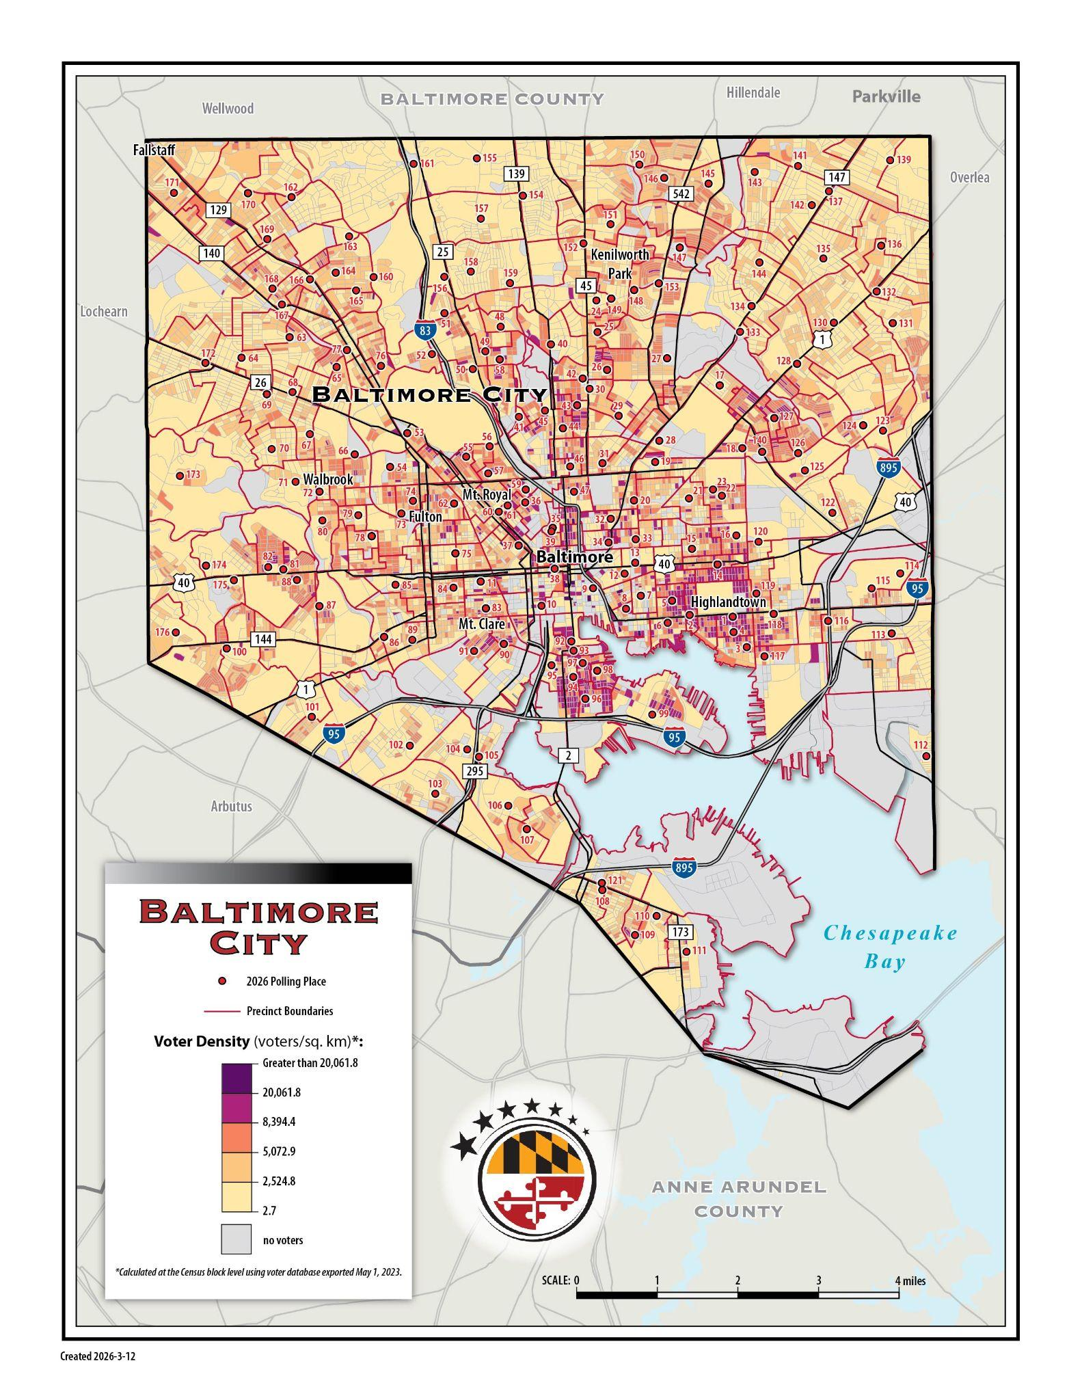

Baltimore City - Historically Disenfranchised Community Analysis

LBE provided the required analysis of the impact on the ability of historically disenfranchised communities to cast a ballot. LBE’s analysis properly showed no negative effect on access to voting for historically disenfranchised communities.

Baltimore City - Minority Population Map

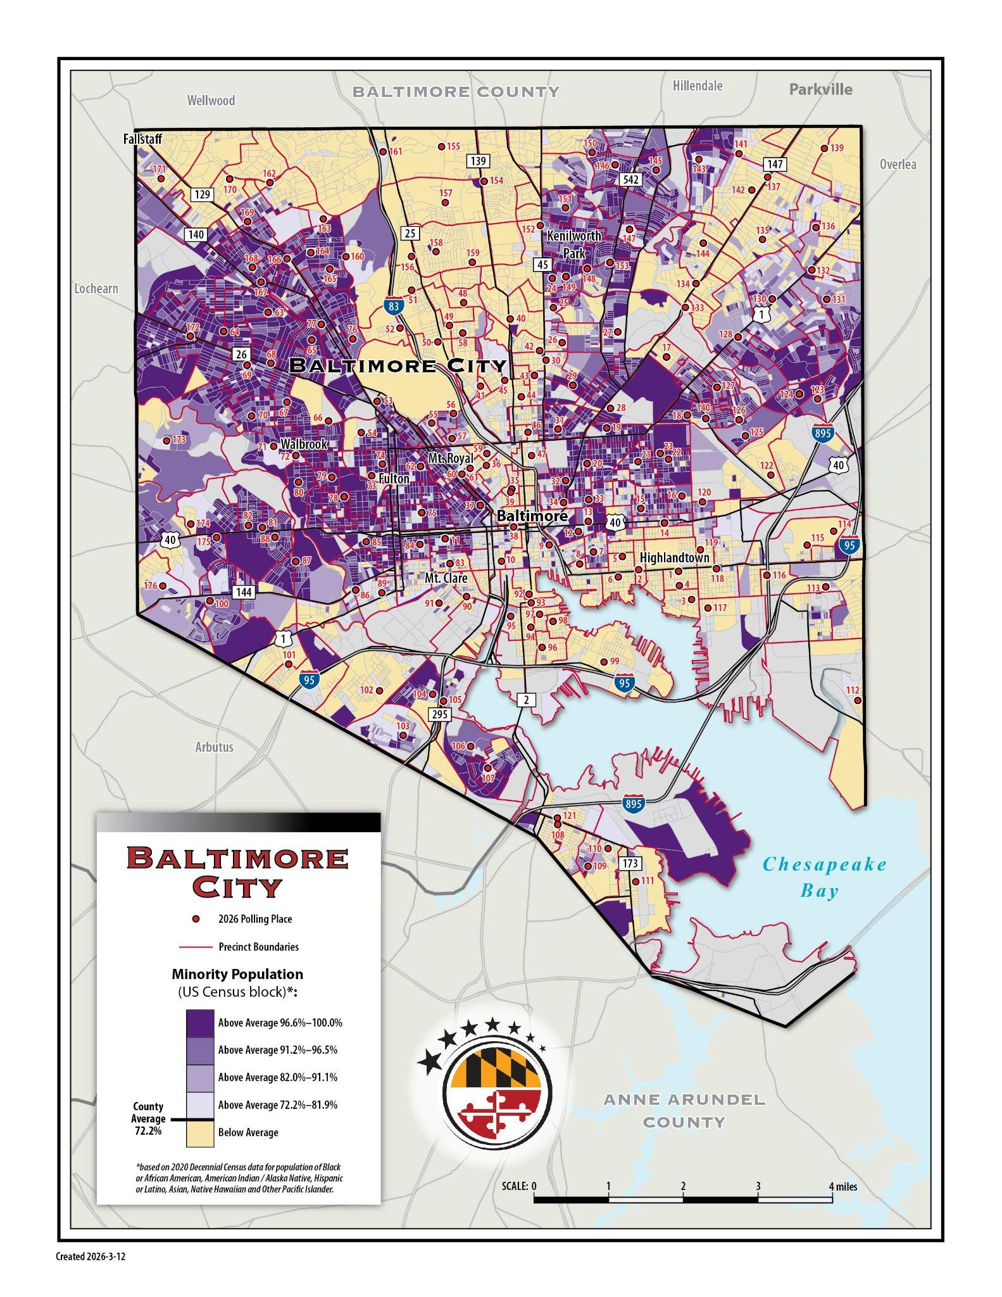
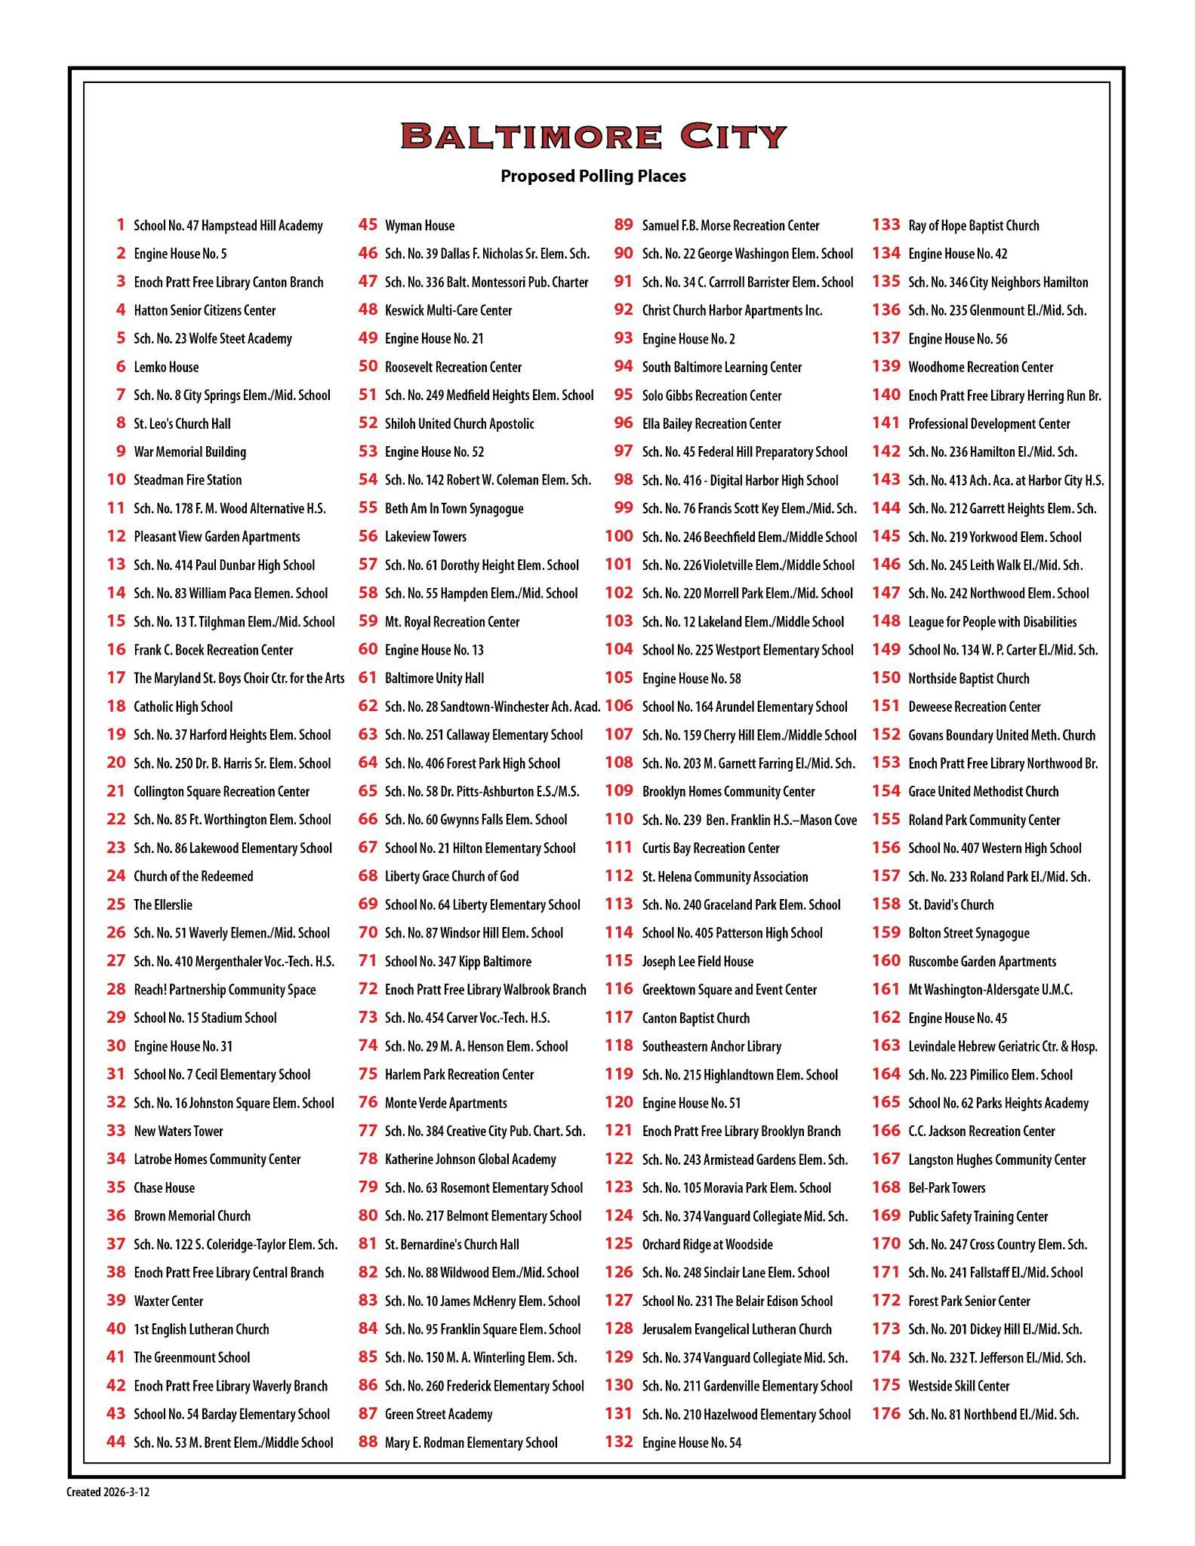

Baltimore City - Income Map

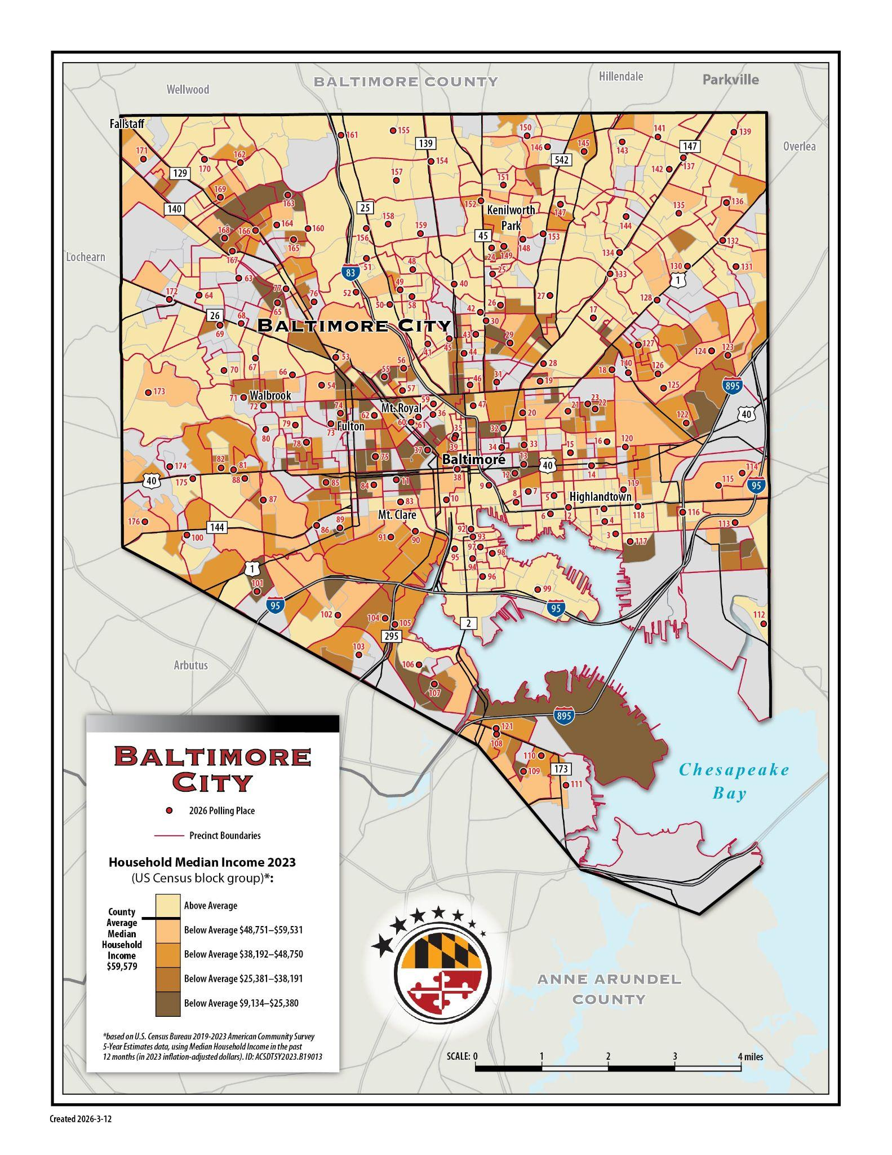

Baltimore City - Voter Turnout Map
